SCENARIO TITLE
Sustainable Road transport management

CATEGORY
Programming, Technology, Environmental Protection

1. SCENARIO IDENTIFICATION
1.1 Scenario Title
Sustainable road transport management.
1.2 Target Age Group
Grades 7–9 (Junior High School)
Curriculum: Junior High School
Thematic Area: Computer systems, digital devices, computer networks
Topics/Subtopics: Automation and robotics - connecting computers with the physical world
Expected Learning Outcomes:
Students will be able to:
- Select and connect devices with sensors, and/or robotic assemblies, to a PC for the purpose of controlling them or recording data.
- Program an application that controls a ready-made robotic device or an automatic control device with simple sensors and actuators as part of a learning project.
- Design and program educational robotics and automation devices for conducting experiments.
- Define the concept of speed and explain its relationship to distance and time.
- Calculate the speed of a robot using the formula Speed=Distance/Time
- Describe how different factors (motor power, surface type) affect the speed and energy consumption of the FOSSBot
- Link the energy efficiency of robots with sustainable transportation and environmental impacts
1.3 Estimated Time
2 teaching hours (90 minutes)
1.4 Subject Areas Involved
Computer Science, Technology, Physics, Environmental Sciences, Mathematics
1.5 Prerequisite Knowledge
Students must be familiar with a visual programming environment. Be able to create programs and correct them. Understand the use and concepts of iteration and selection structures and have applied them in a visual programming environment. Have basic knowledge of measuring length and time.
1.6 Purpose of the Scenario
After completing the scenario, students are expected to:
- Become familiar with using Fossbot sensors FOSSBot components
- Program sensors in combination with other FOSSBot components
- Cultivate their problem-solving skills, adaptation skills and use of new programming and graphical environments through teamwork, collaboration and imagination.
- Understand the concept of speed, how it is calculated and how it is affected by various factors.
- Explore the relationship between speed, energy consumption and environmental impact.

1.6.1 Learning objectives/Outcomes
Students will be able to:
- Handle the FOSSBot interface (login, project import and editing)
- Identify the basic functions and use of sensors (ultrasound)
- Program automation devices with a combination of logical structures (if, else, and)
- Record and interpret sensor values in real-world environmental conditions
- Collaborate in teams, making decisions to design and optimize robot functions.
- Recognize the role of technology in saving energy and enhancing safety
- Use an iterative control structure
- Measure the distance and time traveled by a FOSSBot, using both conventional means and the built-in ultrasonic sensor.
- Calculate the speed of the FOSSBot and analyze how changing the power of the motors affects the speed.
- Compare the energy consumption of FOSSBot at different speeds and draw conclusions about energy efficiency.
- Propose solutions for more sustainable transportation based on the conclusions of the experiment.

1.6.2 Educational objectives
Through teaching, the teacher seeks to:
- Cultivate problem-solving skills through programming activities with a natural look.
- Connect theory with practice, encouraging the investigation of the functioning of sensors.
- Develop collaborative skills through group activities and role-playing.
- Promote creative and critical thinking, giving room for experimentation and free modification of the code.
- Enhance students' environmental awareness through understanding the applications of technology in energy conservation.
- Implement a constructivist approach, where students build knowledge through experience, experimentation and discovery.
- Develop in students the ability to conduct scientific experiments, collect and analyze data, and draw conclusions.
- Enhance understanding of the basic principles of physics (motion, speed, energy) through practical applications

2. LESSON PLAN DEVELOPMENT
2.1 Description of teaching and learning activities
The scenario is based on experiential and exploratory learning, with students working in groups to experiment with FOSSBot and its visual environment. The scenario includes the implementation of three activities through worksheets.
Activity 1 (Speed and Energy): Students become familiar with the main parts of the FOSSBot that contribute to its movement, such as the motor, the wheel, and the batteries. This activity is implemented through an interactive tool like "Find Multiple Hotspots".
Activity 2 (Calculating Distance): Students learn to calculate the distance of FOSSBot from a wall using an ultrasonic sensor. First, they create a variable "distance". Then, they use the "Distance from" tile to assign the distance value to the variable and display it on the application screen.
Activity 3 (Calculating speed, time, and distance traveled ): Students modify the code from the previous activity to calculate the speed of the robot. They program the robot to move straight until it is 15 cm away from a wall. They record the time it took for this path. They create a "time" variable to record the time, activate the timer at the beginning of the code and deactivate it at the end. At the end, they display the elapsed time on the fossbot-app screen. They also change the speed of the motors to 100% and run the project again, observing how this affects time and the relationship between distance, speed, and time.
Activity 4 (Checking comprehension and enhancing metacognitive awareness): This activity aims to assess the understanding of the concepts taught. Students complete a text with gaps by dragging the correct words, such as speed, distance, time, ultrasonic sensor, power, energy, fuel, emissions, and sustainable.

2.2 Worksheets
Activity 1​
Find Multiple Hotspots - "Speed and Energy"
Where in the image below do you find the main parts that contribute to the movement of FOSSBot?
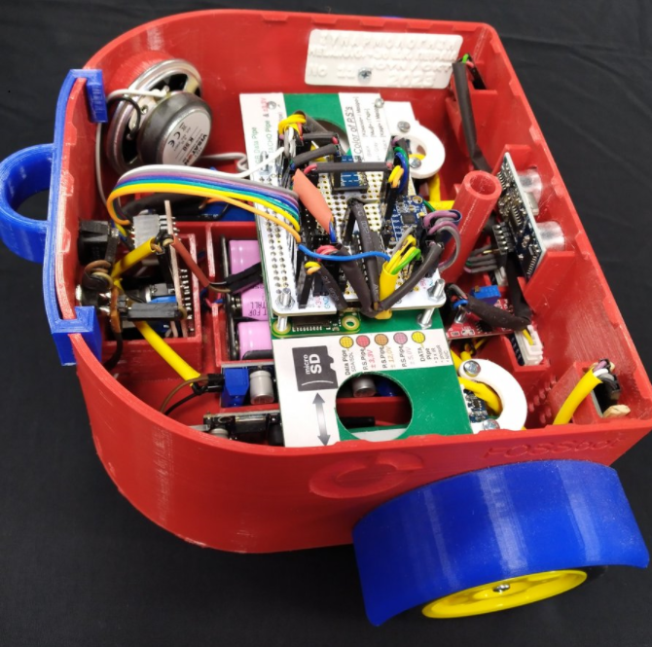
hotspots should be created on the motor, wheel and batteries, like https://h5p.org/find-multiple-hotspots

Activity 2​
Distance calculation
- Open the fossbot - app (Make sure to open CoppeliaSim Edu at the same time)
- Check in the FOSSBot settings that the speed of the left and right motors “Left motor speed 0-100%” and “Right motor speed 0-100%” have the default value of 45%.
- Load the scene “velocity.ttt” into Copellia (File->Open Scene)
- In fossbot - app create a new project . Give it a name and a short description. "Speed calculations".
The goal of this activity is to calculate the distance of the FOSSBot from the wall and display this value on the fossbot - app screen.
- Create a distance variable (Variables-Create Variable..-“distance”)
- Initialize the value of the distance variable to 0
- Display this value on the fossbot-app screen 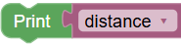. Check the result.
- Modify the display of the value on the screen so that it is accompanied by an appropriate indication, e.g.: Distance = 0. Check the result.
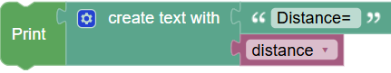
Don't forget to save your work regularly.

- Recording the value of the FOSSBot distance sensor from an object is achieved with the tile .
- This value must be assigned to the variable “distance” and displayed on the screen as in step 8.
- In summary, the tiles used in this activity are the following:
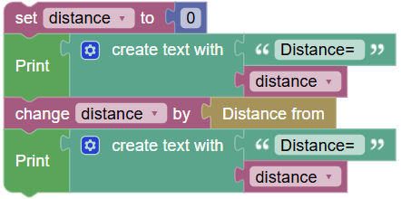
- What is the distance of the FOSSBot from the obstacle (wall) you see in the scene?
…………………………………………………………………………………………………………………………………………………………………………………………………………………………………………………………

Activity 3​
Calculation of speed, time, and distance traveled
Using the code from Activity 2 modify your program by following these steps:
- Program your robot to move straight up to 15 cm from the scene obstacle.
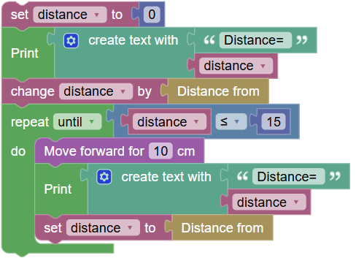
- Record, observing Copellia, how long it took her to travel this distance.
……………………………………………………………………………………………………………………………..
- Create a variable “time ” to record the time from fossbot-app and initialize it (value=0) 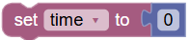.
- Where in the code should you place this tile?
…………………………………………………………………………………………………………………….……..
- Enable the timer at the beginning of the code
- At the end of the code (excluding repetition) the elapsed time should be displayed on the fossbot-app screen.
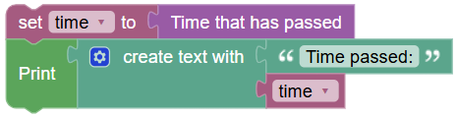
- Disable the timer at the end of the code
- Save your project and go to the app home page 
- Go to FOSSBot settings and change the left and right motor speed values “Left motor speed 0-100%” and “Right motor speed 0-100%” to 100%. Save the changes of the parameter
- Go back to the velocity project and run it again.
- What value does the variable time have now?
……………………………………………………………………………………………………………………………
- How do you interpret this?
……………………………………………………………………………………………………………………………
……………………………………………………………………………………………………………………………..
Distance, speed, and time are linked by a basic physical relationship. The distance traveled is the product of the speed times the time it takes to travel the distance.
Distance = Speed * Time
Therefore, if time remains constant, distance is affected linearly by speed. This means that if you double your speed, you will also double the distance you travel in the same amount of time.
- Discuss how moving at higher speeds affects the environment.
Activity 4​
Checking comprehension and enhancing metacognitive awareness.
Drag & Drop the words (H5P: Drag the Words) - "Fill in the Blanks: ":

Speed and the Environment
In the text below, fill in the gaps by dragging the correct words.
Words to Drag: speed, distance, time, ultrasonic sensor, power, increased, energy, fuel, emissions, sustainable.

Text: In the experiment with FOSSBot , we measured the [speed] of the robot. To do this, we needed to measure the [distance] it traveled and the [time] it took to move. The formula we used is Speed=Distance/Time. For more accurate distance measurements, we can use the [ultrasonic sensor] of FOSSBot. We noticed that when we increased the [power] of the motor, the speed of FOSSBot [increased]. This means that the robot consumes more [energy] when it moves faster. In the real world, choosing the right [speed] can reduce [fuel] consumption and pollutant [emissions], contributing to [sustainable] transportation.

