SCENARIO TITLE
Learning about the Environment

SUBJECT
Environmental Protection/Technology/Programming

1. SCENARIO IDENTIFICATION
1.1 Scenario Title
Learning about the Environment.
1.2 Target Age Group
Grades 7–9 (Junior High School) .The activities are differentiated according to the class level, with the aim of adapting the difficulty and depth to the characteristics of each age group.
Curriculum: Junior High School
Thematic Area:
The scenario falls within the interdisciplinary field of "Environmental Protection through Technology and Programming". It focuses on introducing students to:
- The basic principles of environmental protection and sustainable development.
- Understanding everyday concepts such as: recycling, renewable energy sources, climate change and ecological footprint.
- The use of automation and robotic devices (FOSSBot) as tools for monitoring and addressing environmental issues.
- The development of programming, design and team problem-solving skills with an emphasis on connecting computers with the physical world.
The purpose of the thematic area is for students to understand how technology and programming can contribute positively to protecting the environment and improving the quality of life.
Topics / Subtopics:
- Automation and robotics
- Connecting computers to the physical world
- Understanding and applying environmental protection concepts
- Basic principles of sustainable development, recycling, renewable energy sources and ecological footprint

Expected Learning Outcomes:
Students will be able to:
- Recognize and describe the function of simple sensors and calibrate them.
- Communicate effectively and collaborate in teams to design solutions to STEM problems related to the environment
- Work in a programming environment ( FOSSBot ) to solve problems with real applications
- Practice and develop problem-solving skills, adaptation and selection of appropriate programming or graphical tools
- Connect technology/programming concepts with sustainable development issues

1.3 Estimated Time
45 minutes.
1.4 Subject Areas Involved
Computer Science, Technology
1.5 Prerequisite Knowledge
Students should have:
- Basic familiarity with the use of computers and simple graphical environment applications.
- Introductory programming knowledge (commands, sequential and simple structured thinking).
- Understanding of physics concepts, such as what a sensor/measurement is, and introductory knowledge from Technology or Science courses.
- Familiarity with teamwork and collaborative problem solving.
1.6 Purpose of the Scenario
The purpose of the scenario is to highlight how automation technologies, robotics and programming can be used to raise awareness and study key environmental protection issues (such as recycling and renewable energy sources). Through experiential and exploratory activities, students connect theoretical concepts with practical applications, using FOSSBot and its corresponding software.
1.6.1 Learning objectives/Outcomes
Upon completion of the scenario, students will be able to:
- They explain the operation of basic sensors and test their calibration.
- They manipulate the FOSSBot interface environment and enter basic programming commands to automate actions related to the environment.
- They recognize fundamental environmental protection concepts such as sustainable development, recycling and renewable energy sources.
- They collaborate effectively in teams to design and implement solutions to real-world problems.
- They utilize metacognitive skills, such as self-evaluation, drawing conclusions, and critically approaching their results.

1.6.2 Teachingl objectives
Through teaching, the teacher seeks to:
- Strengthening students' digital and technological literacy.
- The development of problem-solving and creative thinking skills in the STEM context.
- Cultivating responsible citizen attitudes in relation to environmental issues.
- Strengthening collaboration, communication and self-determination in the classroom.
- Promoting a unified way of connecting science, technology and their applications in everyday life.

2. DEVELOPMENT OF A TEACHING PLAN
2.1 Description of teaching and learning activities
The scenario utilizes a series of modern, interactive and experiential activities focused on programming and robotics, which enhance both the understanding of fundamental computer science concepts and the interdisciplinary approach to environmental issues.
Flow and content of activities
Activity 1 : Introduction to concepts related to environmental protection (H5P: Find the Words)
Students begin with the interactive activity "Find the Words" in the H5P environment, where they identify key concepts that they will encounter in the scenario, such as " SUSTAINABLE DEVELOPMENT", "RECYCLING", "CLIMATE CHANGE , etc.
The activity functions as a familiarization with the vocabulary of the lesson and as a diagnostic exercise for the students' initial knowledge.
Activity 2: Experimenting with FOSSBot
Students work in teams, interacting with the virtual robot FOSSBot in Copellia and its programming environment. They undertake to create or modify an initial program so that the robot can detect and react to the track line with sensors.
Through experimentation and guided investigation, they test small changes to the code (e.g. calibration or termination conditions), developing problem-solving and collaboration skills.
Activity 3 : Connecting robotics with sustainability
Students program the FOSSBot to follow a path on a black line with stops at corresponding points, thus connecting technological skill with a practical understanding of environmental protection issues.
Activity 4 : Evaluation and reflection (H5P: Drag the Words)
The last activity is based on the H5P “Drag the Words” tool, where students are asked to complete sentences or words related to the key concepts taught, choosing the correct ones from a list.
It serves as a means of assessing comprehension, as well as a trigger for discussion and metacognitive processing.
In addition, it provides an opportunity for a brief self-assessment and to draw conclusions both regarding technological progress and their attitude towards environmental issues.
Pedagogical approach
- Interactive and collaborative learning is incorporated: The use of H5P modules promotes active participation, while group experimentation with FOSSBot enhances collaboration.
- Gradual deepening: Activities are designed to move from understanding and using basic concepts to application, synthesis and reflection.
- Connecting theory and practice: Technological literacy is combined with the principles of environmental awareness, maintaining the interest of students and the usefulness of the knowledge they acquire.

2.2 Worksheets
Activity 1
Find 7 words in H5p - Find the words related to environmental protection.
The words that students should find are:
- SUSTAINABLE DEVELOPMENT
- RECYCLING
- CLIMATE CHANGE
- RENEWABLE
- ECOLOGICAL FOOTPRINT​​​
- POLLUTION
- BIODIVERSITY
Activity 2
Black line sequence
- Open the FOSSBot App.
- Go to the home page of the FOSSBot interface.
- Create a new project .
- Name it " I'm Learning About the Environment."
- Load the scene “environmental_concepts.ttt” into Copellia .
- Use the following tiles to make FOSSBot follow the black line until the “ END ” point, where it encounters an obstacle.

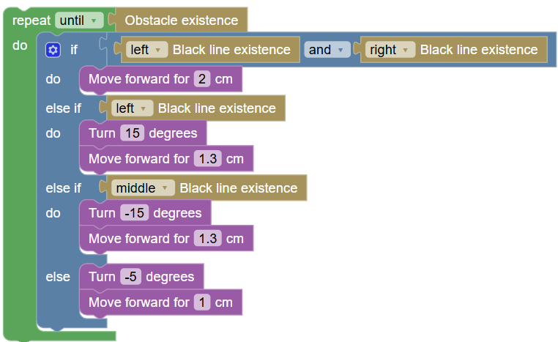
- Save changes
- Run the project.
- What do you observe?
…………………………………………………………………………………………………………………. .. …………………………………………………………………………………………………………………..
- Stop the project execution . What's happening?
…………………………………………………………………………………………………………………. .. …………………………………………………………………………………………………………………..

Activity 3
Use of variables. Attitudes to concepts related to environmental protection
In this activity the robot will be in a starting position ( START ). When the program is executed the FOSSBot must record five (5) horizontal lines that intersect the track. There you should record what you know about each concept.
- Create a variable “ lines ” to count the horizontal lines that intersect the track.

Create variable

lines
- Initialize the variable “ lines”
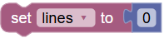
- Modify the code of the Activity 2 so that FOSSBot detects the next horizontal line that intersects the track. The horizontal line will be detected with the right line sensor.
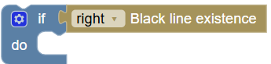
- The variable “ lines ” will increase by 1 unit
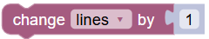
- The value of the lines will be displayed on the FOSSBot screen. App
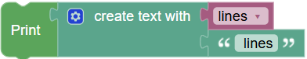
- In summary, the tiles for recording the horizontal lines that intersect the track will have the following format:
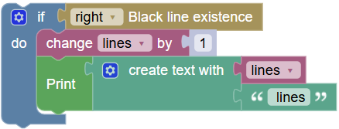
- Write down what you know about the following concepts.
" Sustainable Development": ………………………………………………………………………………………………….
…………………………………………………………………………………………………..
…………………………………………………………………………………………………
Recycling : …………………………………………………………………………………………………………
……………………………………………………………………………………………………….
…………………………………………………………………………………………………………
Climate Change: …………………………………..……………………………………………………………………….
…………………………………………………………………………………………………………..
………………………………………………………………………………………………………………..
Renewable Energy Sources
…………………………………………………………………………………………………………………..
……………………………………………………………………………………………………………………..
………………………………………………………………………………………………………………………
Ecological Footprint
…………………………………………….……………………………………………………………………….
………………………………………………………………………………………………………………………
……………………………………………………………………………………………………………………..
Note: For the smooth completion of the activities, you may need to modify some parameters-values of the FOSSBot virtual robot , such as speed, rotation angle, rolling distance, etc.
Activity 4
Open Drag the Words on h 5 p . In each gap in the sentences describing environmental concepts you find, drag the appropriate definitions.
The word-sentences that will be used are the following:
Sustainable Development : Development that meets the needs of the present without compromising the ability of future generations to meet their own needs.
Recycling : The process of converting waste into reusable materials, with the aim of reducing pollution and the consumption of raw materials.
Climate Change : The gradual change in the Earth's climate due to human activities, mainly from the emission of greenhouse gases.
Renewable Energy Sources : Energy sources such as the sun, wind, water and biomass that are inexhaustible and environmentally friendly.
Ecological Footprint : The amount of natural resources that a person or a society consumes to support its way of life.

