SCENARIO TITLE
Environmental Patrol

SUBJECT
Environmental Protection/Technology/Programming

1. SCENARIO IDENTIFICATION
1.1 Scenario Title
Environmental Patrol

1.2 Target Age Group
Grades 7–9 (Junior High School)
Curriculum: Junior High School
Thematic Area: Algorithms and computer systems programming/Environmental Protection
Topics/Subtopics: Problem solving with programming tools. Robot programming and automation
Expected Learning Outcomes:
Students will be able to:
- Recognize the function of various sensors and their applications in automation and environmental projects.
- Design, assemble and program complex robotic devices in the context of educational projects with simple logical structures (if, repeat, and) using a visual programming environment.
- Collect and analyze data from light, sound and ultrasound sensors in real-world conditions.
- Apply obstacle avoidance techniques with a robot moving in a natural space.
- Develop environmental sensitivity, understanding how technology can be used to monitor and protect the environment.
- Work together to solve authentic problems, following experimentation, testing and optimization processes.
- Develop metacognitive skills, identifying errors in the code and evaluating the functionality of their solutions.

1.3 Estimated Duration
45 minutes

1.4 Subject Areas Involved
Scenario topic:
Use of educational robotics for environmental monitoring and awareness. Students program FOSSBot to detect noise, obstacles, light pollution and contribute to environmental protection actions.
Subjects:
- Informatics (visual programming, sensors, automation)
- Technology (sensor functions, recording environmental data)
- Environmental Education (awareness of noise pollution, light pollution, sustainable development)
- Natural Sciences (interaction of physical quantities with technological systems)

1.5 Prerequisite Knowledge
Students are expected to:
- Have basic familiarity with visual programming environments like Scratch
- Know concepts such as repetition and selection structures (repeat, if)
- Be familiar with the concept of a sensor and its basic use in the context of automation
- Have basic experience using FOSSBot (such as basic movement commands)

1.6 Purpose of the Scenario
- The scenario seeks to connect the use of technology with environmental observation and awareness. Students will gain experience in programming sensors to collect and utilize data from the natural environment, developing problem-solving, collaboration, and ecological awareness skills.

1.6.1 Learning Objectives/Outcomes
Students will be able to:
- configure FOSSBot to detect obstacles with ultrasound
- modify parameters in the light and sound sensor
- create programs with logical conditions and repetition
- use sensors to create robotic applications for environmental purposes
- interpret data from sensors and correlate it with real environmental parameters
- collaborate in teams to design and improve robotic patrol solutions

1.6.2 Teaching Objectives
Through teaching, students will be involved in::
- Inquiry activities where they are asked to solve authentic problems
- Understanding the relationship between technology and environmental monitoring
- Experimenting with sensors to identify environmental parameters
- Enhancing collaborative learning and role sharing
- Developing environmental sensitivity and applying technology with a social orientation

2. LESSON PLAN DEVELOPMENT
2.1 Description of Teaching and Learning Activities
Teaching is based on experiential and exploratory learning. Students work in small groups (3-5 people), programming the FOSSBot to function as an "environmental patrol", detecting and recording important environmental parameters (sound, light, obstacles).
The flow of activities includes:
- 1st activity: Obstacle detection with an ultrasonic sensor and setting trigger values
- 2nd activity: Moving the FOSSBot in a confined space while avoiding obstacles and using sound alerts
- 3rd activity: Noise pollution detection with a light alert
- 4th activity (optional): Measuring light pollution
- Assessment activities: Quiz of matching sensors with functions, identifying programming structures (hotspots)
The educational process is enhanced by the integration of gamification and interactive assessment elements through the H5P platform.
To implement the activities, FOSSBot must first be synchronized to the local Wi-Fi network.

2.2 Worksheets
Activity 1
- Open the FOSSBot. Wait a few seconds for it to connect to your local network.
- On a computer or laptop connected to the same network as the robot, open Chrome or Firefox and go to the URL: http://fossbot-000.local:8081 to access the FOSSBot interface.
- Upload the project “obstacle black box.xml”.
- Click Edit.
- Run the project.
- What do you observe?
………………………………………………………………………………………………………………………..
………………………………………………………………………………………………………………………..
- Go to the homepage of the FOSSBot interface.
- Select settings
- Change the value to “obstacle detected True if sensor value smaller than” so that FOSSBot stops relatively close to any obstacle. Save the changes.
- Return to editing mode on the task “obstacle black box.xml”.
- Run  the project.
- What do you observe?
……………..………………………………………………………………………………………………………..
………………………………………………………………………………………………………………………
- If FOSSBot does not stop in the correct position you expected, repeat steps 7-12.

Activity 2
Movement in a limited enclosed area (square frame), use of ultrasound to avoid obstacles
- Using the code from the 1st activity, modify your program, using the following tiles, so that FOSSBot moves continuously in an enclosed space, avoiding obstacles.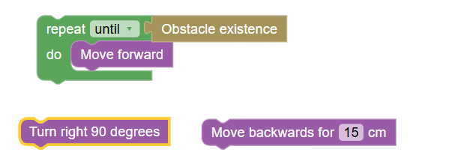
- Study the surface that the FOSSBot is moving on for friction. Change the value in “Set Rotate left/right (on simulator 1 = 90, on physical robot steps )” so that the FOSSBot makes a complete right angle at the 90° turn. Save the changes..
- When an obstacle is detected, the sound clip “empodio” will be played.

- Additionally, using the following tiles in the appropriate order, set the FOSSBot to move forever in space
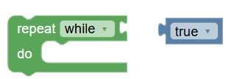

Activity 3
Noise measurement
In this activity, we will utilize a sound sensor on the FOSSBot to detect noise pollution. A sound sensor can be used to monitor and record noise levels in urban, industrial, or natural areas. The robot could detect excessive noise from construction sites, factories, or vehicles, providing data for enforcing limits and reducing noise pollution. For example, in a protected area, it could detect noise from unauthorized vehicles or activities.
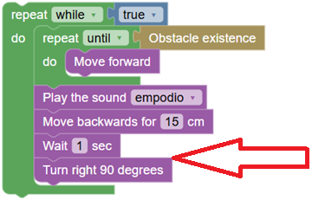
- As a continuation of the 2nd activity, additionally use the following tiles in the appropriate order, before turning right, so that when the FOSSBot sound sensor detects a sound, it flashes a red-white light for 5 seconds.
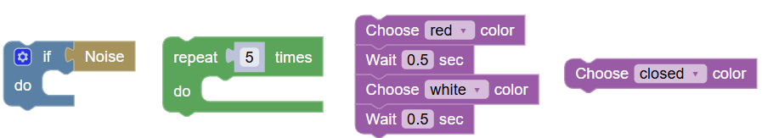

Activity 4 (Optional-Homework)
A patrol robot equipped with light sensors can significantly contribute to environmental protection in many innovative ways, such as detecting light pollution. A light sensor can measure the levels of artificial light in outdoor spaces. This is crucial in addressing light pollution, which affects wildlife (especially nocturnal animals), disrupts natural rhythms and makes it more difficult to observe the night sky.
Program the FOSSBot appropriately to detect areas with excessive or inappropriate lighting, with the light sensor (photoresistor). When the brightness exceeds the desired limit, the LED flashes green for 5 seconds.

Activity 5 Assessment activity (Matching quiz)
h5p will be used, such as https://h5p.org/drag-the-words, and students will drag the sensors into the blank (……). The order of the words should be mixed
Match the sensors that can be adapted to a robot to the appropriate environmental functions and automations.

Environmental Functions and Automation | Robot Sensors
Light pollution detection and lighting optimization. Sensor ……….. | Light
Noise pollution detection and wildlife monitoring. Sensor ……….. | Sound
Climate change monitoring and fire detection. Sensor ……….. | Temperature
Monitoring soil and atmospheric conditions for precision agriculture. Sensor ……….. | Humidity
Air pollutant detection and emissions monitoring. Sensor ……….. | Gases (e.g. CO2, Methane)
Detecting human or animal presence for energy saving or security. Sensor ……….. | Motion (PIR)
Night vision and thermal imaging for search and rescue. Sensor ……….. | Infrared (IR)
Water level or pressure monitoring in irrigation systems. Sensor ……….. | Pressure
Distance measurement and obstacle avoidance. Sensor ……….. | Ultrasonic

Where in the code in the image below do you find a repetition structure?
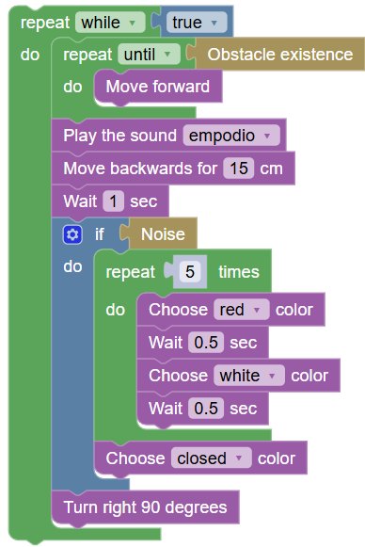
3 hotspots should be created in the repeats, like https://h5p.org/find-multiple-hotspots

