SCENARIO TITLE
Green S.T.E.P.S with FOSSBot
SUBJECT
Environmental Education, ICT, and Robotics Integration

1. SCENARIO IDENTIFICATION
1.1 Scenario Title
Green Steps with FOSSBot
1.2 Target Age Group
Grades 5–6 (Secondary School)
Curriculum: Lower Secondary School
Thematic Area: Sustainability and Environmental Awareness, Digital Literacy and Computational Thinking, Active Citizenship and Responsibility, STEM Integration for Sustainability
Topics/Subtopics: Energy saving, waste reduction, and responsible daily habits.
Expected Learning Outcomes:
By the end of the scenario, students will be able to:
- Identify environmentally responsible and irresponsible daily actions.
- Explain how simple technological tools like FOSSBot can promote sustainable behaviors.
- Apply basic programming logic (e.g., if/else conditions) to model environmental decisions.
- Demonstrate awareness of how small individual choices contribute to broader sustainability goals.
- Collaborate effectively during group tasks and share ideas for eco-friendly actions in their school environment.
- Reflect on their learning experience and the connection between coding, responsibility, and sustainability.

1.3 Estimated Duration
45 minutes

1.4 Subject Areas Involved
Computer Science, Environmental Science, Mathematics

1.5 Prerequisite Knowledge
Before engaging in this scenario, students should have Basic Digital Literacy Skills, Introductory Coding Experience, Awareness of Environmental Concepts, Teamwork and Communication Skills, and Observation Skills.
1.6 Purpose of the Scenario
The purpose of this scenario is to engage students in understanding the relationship between technology, everyday behavior, and environmental responsibility through simple, hands-on robotics activities. Using FOSSBot as an educational tool, students explore how coding and automation can represent eco-friendly actions and promote sustainable thinking.
1.6.1 Learning Objectives/Outcomes
By the end of the scenario, students will be able to:
- Explain how the carbon footprint is calculated.
- Input and process environmental activity data using FOSSBot.
- Interpret results to propose emission reduction actions.
- Collaborate to design technological solutions for climate change mitigation.
- Use metacognitive strategies for self-assessment and critical thinking.

1.6.2 Teaching Objectives
Through teaching, the educator aims to:
- Promote awareness of how individual behaviors affect the environment and inspire responsibility through concrete classroom examples.
- Encourage active engagement by integrating hands-on robotics activities that connect digital learning with real-world environmental contexts.
- Foster collaboration and dialogue among students while supporting teamwork, empathy, and shared problem-solving.
- Integrate technology meaningfully into environmental education to demonstrate that digital tools can serve sustainability goals.
- Develop transversal skills such as creativity, digital competence, and critical thinking within sustainability-focused tasks.
- Cultivate reflection and values education, helping students internalize the importance of eco-conscious living beyond the classroom.

2. LESSON PLAN DEVELOPMENT
2.1 Description of Teaching and Learning Activities
In this lesson, students engage in three sequential, hands-on activities designed to connect environmental awareness with basic programming and logical thinking.
Each activity combines real-world sustainability actions with block-based coding, showing how technology can represent and promote responsible habits.
Through observation, simple decision-making, and collaboration, students learn that even small “green steps” can lead to meaningful environmental change.
The scenario integrates environmental education, digital literacy, and values-based reflection, aligning with the principles of GreenComp and SDGs 4.7, 12, and 13.
In the Green Steps with FOSSBot scenario, students progress through three short, interrelated activities that blend environmental awareness with simple programming practice. Each activity connects to an everyday sustainability theme—energy use, water conservation, and environmental responsibility—while guiding students to translate these ideas into digital actions through the FOSSBot interface.
In Activity 1, “Green or Not Green,” students explore everyday sustainability by working through short, context-based sentences in an H5P drag-the-words task. Each sentence describes a familiar situation—like taking a short shower or leaving the tap running—and students decide whether the behavior is eco-friendly or wasteful. As they place the correct category into each blank, they receive immediate feedback. Meanwhile, FOSSBot supports the activity by flashing green when a sustainable habit is discussed and yellow when a harmful one appears. Through this simple interaction, students begin to see how small daily choices influence the environment.
In Activity 2, “Sustainability Signals,” students learn how robots can model environmental decision-making using simple conditional logic. students trigger different “daily-life situations” by selecting behavior cards. Each card represents a typical scenario—saving water, wasting energy, reducing waste, or overusing resources. Through this exercise, students see how conditional statements such as if–else can be used not only in coding but also to represent environmental consequences in an engaging and physical way.
Finally, Activity 3 “Eco-Logic Check” is a short multiple-choice quiz designed to review key sustainability concepts. Students answer five questions related to energy saving, water conservation, waste reduction, and responsible consumption. The quiz encourages learners to apply what they practiced in the previous activities. It helps them distinguish between sustainable and harmful daily habits. This activity also provides a quick assessment of students’ environmental understanding.

2.2. Worksheets
Activity 1
Green or Not Green
H5P will be used, such as https://h5p.org/drag-the-words. Students will read each statement and complete the missing part by dragging the appropriate word.
The teacher explains that students will explore common daily behaviors and decide whether each one is environmentally friendly or harmful. Students are placed in pairs or small groups. Students access the “Green or Not Green” H5P drag-the-words exercise on their devices. The teacher briefly demonstrates how to drag the correct category (Green Habit / Not Green Habit) into each blank. Students read a series of short, real-life sentences describing actions such as taking short showers, throwing away food, or using a reusable bottle. Before dragging an answer, group members talk about whether the described behavior is sustainable and why. This encourages reasoning and environmental awareness. Students finish the set of scenarios and compare their results with other groups.
Scenario | Draggable Words (Correct Answer)
💡 Élise always switches off the lights when she leaves the room, showing a… | [Green Habit]
🚰 During breakfast, Nikos leaves the tap running while searching for a clean cup, which is a... | [Not Green Habit]
🌿 Before going to school, Berk fills his reusable water bottle instead of buying plastic ones, so this is a… | [Green Habit]
🍞 At lunchtime, Alejandro throws away part of his sandwich even though it is still edible, making this a… | [Not Green Habit]
🚿 Every evening, Zofia takes short 8-minute showers to save water, which is a… | [Green Habit]
🛁 Her cousin Mateusz often stays in the shower for more than 20 minutes, which is a… | [Not Green Habit]
🔌 Before sleeping, Céline leaves her phone charging all night long, which is a … | [Not Green Habit]
✏️ While preparing his homework, Yiannis uses both sides of his notebook pages to avoid wasting paper, showing a… | [Green Habit]
🍫 In the schoolyard, Leyla sometimes drops snack wrappers on the ground instead of using the bin, which is a… | [Not Green Habit]
📄 In art class, Alejandro and his group recycle leftover paper scraps, demonstrating a… | [Green Habit]

Reflection discussion
The teacher asks a few closing questions:
Which habits were easiest to identify? Why?
_______________________________________________________
Which ones surprised you?
_______________________________________________________
What is one green habit you can adopt this week?
_______________________________________________________

Activity 2
Sustainability Signals
In this activity, students record and interpret FOSSBot’s reactions. For each behavior card selected, learners observe whether the action is sustainable or harmful and note the robot’s response—movement, LED color, and sound. Students complete the table by matching each behavior with the correct reaction pattern. A short reflection section at the end encourages them to think about which habits made the robot move forward and which triggered warnings.
To run the project follow these steps:
- Open the FOSSBot. Wait a few seconds for it to connect to your local network.
- On a computer or laptop connected to the same network as the robot, open Chrome or Firefox and go to the URL: http://fossbot-000.local:8081 to access the FOSSBot interface.
- Go to the homepage of the FOSSBot interface.
- Create a new project .
- Name it “Sustainability Signals”.
- In the “short description for the new project,” you may write a description related to the activity.
- Firstly, Go to Variables, click create a variable, create:
behaviorType
selectedBehavior
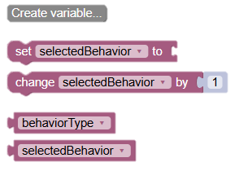
- From Loops, Add a repeat block to run multiple times, you should write “5”

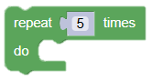
- Inside the repeat block , Drag set selectedBehavior to “text” leave it as a text input that it can be manually changed (e.g., “short_shower”, “tap_running”, “recycle_paper”). (Teacher will change it and click Run again for each card)
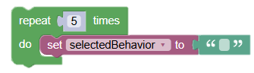

- Inside the repeat block, under the “set selectedBehavior”:
Add an IF / ELSE IF / ELSE block
- Add a SECOND IF structure directly under the first one. For sustainable behaviour; add the structure in order, if (behaviorType = "sustainable"), print= “Well Done”. For unsustainable behaviour; add else if (behaviorType = "unsustainable"), print= “Be careful, it’s unsustainable”
At the end, the blocks should be seen as below:
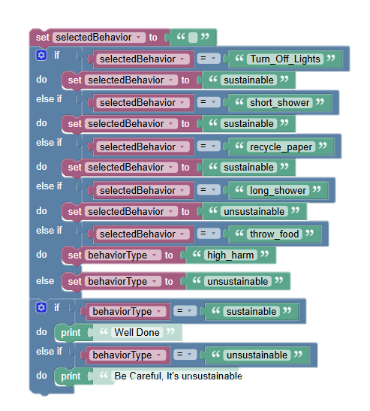

- The robot will perform 5 teacher-selected behaviors. Teacher changes selectedBehavior each loop manually and clicks Run  for each round.

Reflection Questions
- Which behavior made the robot react positively, and why was it considered sustainable?
_____________________________________________________________________________________________________________________________________________________________________________________________
- Which behavior triggered a warning (yellow or red LED), and what environmental problem does it relate to?
_____________________________________________________________________________________________________________________________________________________________________________________________
- How did the robot’s reactions help you understand the difference between sustainable and harmful habits?
_____________________________________________________________________________________________________________________________________________________________________________________________
- What is one daily habit you would like to improve after this activity, and why?
_____________________________________________________________________________________________________________________________________________________________________________________________

Activity 3
Eco-Logic Check

Choose the correct options
1. Which of the following is a sustainable daily habit?
A) Leaving the tap running while brushing teeth
B) Using a reusable water bottle
C) Charging your phone all night
D) Throwing away edible food

2. Which habit helps reduce unnecessary waste in daily life?
A) Printing every worksheet instead of using digital copies
B) Throwing away school supplies at the end of each term
C) Reusing items like folders or pencil cases instead of buying new ones
D) Buying extra materials “just in case”

3. Which habit is most helpful for conserving water?
A) Letting the tap run while brushing teeth
B) Taking a long shower to relax
C) Turning off the tap when not using it
D) Washing small loads of laundry separately
4. Which choice shows responsible food consumption?
A) Buying more food than you need “just in case”
B) Throwing away fruits with small bruises
C) Planning meals and using leftovers
D) Leaving food on your plate
5. Which daily action supports reducing energy consumption at home or school?
A) Leaving devices plugged in when not needed
B) Keeping windows open while the heater is on
C) Switching off unused devices
D) Using only artificial light during daytime
Correct Answers:
1.B 2.B 3.C 4.C 5.C

Note: To implement the activities, the FOSSBot must be pre-synchronized with the local Wi-Fi network and pre-programmed with the appropriate automated behavior logic.

