SCENARIO TITLE
Probability Adventure with FOSSBot

SUBJECT
Mathematics

1. SCENARIO IDENTIFICATION
1.1 Scenario Title
Probability Adventure
1.2 Target Age Group
Grades 8 ( Secondary School )
Curriculum: Secondary School
Thematic Area: Mathematics, Computational systems, Digital devices
Topics/Subtopics: Basic Probability, Experimental and Theoretical Probability
Expected Learning Outcomes:
Students will be able to:
- Define basic probability using the formula P(A) = favorable outcomes ÷ total outcomes.
- Differentiate between theoretical and experimental probability.
- Conduct experiments using random events (dice, coins, colored cards) simulated with FOSSBot.
- Record results, create tables, and compare probabilities.
- Use FOSSBot’s random number generation, LED, and sound features for applied mathematics experiments.

1.3 Estimated Duration
40 minutes

1.4 Subject Areas Involved
Computer Science, Technology, Mathematics

1.5 Prerequisite Knowledge
Students should know the concept of fractions. They should have basic knowledge of probability. Students must be familiar with FOSSBot interface basics.

1.6 Purpose of the Scenario
By the end of the lesson, students should have:
- Practiced calculating theoretical probability.
- Collected data to estimate experimental probability.
- Used technology (FOSSBot) to visualize randomness.
- Improved collaborative problem-solving through group tasks.
- Understood how randomness connects math theory with real-world experiments.

1.6.1 Learning Objectives/Outcomes
Students will be able to:
- Simulate random events using random integer blocks.
- Record results of repeated trials and analyze data.
- Compare theoretical and experimental probabilities.
- Work collaboratively in groups to conduct probability experiments.
1.6.2 Teaching Objectives
Through teaching, the educator aims to:
- Strengthen understanding of probability concepts through practical experiments.
- Encourage collaborative learning via group activities.
- Link mathematics with digital technology and robotics.
- Promote curiosity and critical thinking by exploring randomness.
- Provide a gamified learning experience with FOSSBot.

2. LESSON PLAN DEVELOPMENT
2.1 Description of Teaching and Learning Activities
This scenario applies inquiry-based and experiential learning using FOSSBot’s random blocks, LED, and sound. Students will explore probability concepts by conducting experiments where randomness is simulated digitally.
The lesson is divided into activities:
Activity 1: Introduction to Probability and FOSSBot Randomness
Students are introduced to probability formulas. FOSSBot is used to generate a random number (1–3). LEDs represent different outcomes (e.g., red=1, green=2, blue=3). Students predict the outcome, run the code, and check results.
Activity 2: H5P True / False Activity
Students will read each statement and decide whether it is True or False based on what they learned in Introduction to Probability and FOSSBot Randomness. This activity helps review key ideas about randomness, prediction, and experimental probability.
Activity 3: Probability Quiz Parkour
FOSSBot moves through a mini-parkour with 3 stops (stations). At each stop, students answer a probability question (e.g., coin toss, colored balls in a bag).
- If correct → LED green + short sound.
- If incorrect → LED red + long sound.

2.2 Worksheets
Activity 1
In this activity, we aim to explore probability and randomness by programming FOSSBot to generate random outcomes and visualizing them through LED colors. Students will learn how to make predictions, collect data, and compare theoretical probability with experimental results.
Each time the program runs, FOSSBot randomly chooses one of three LED colors:
- 🔴 Red → Represents number 1
- 🟢 Green → Represents number 2
- 🔵 Blue → Represents number 3
Students first predict which color they think will appear most often, then run the robot repeatedly to record results and discuss randomness.
To run the project follow these steps:
- Open the FOSSBot. Wait a few seconds for it to connect to your local network.
- On a computer or laptop connected to the same network as the robot, open Chrome or Firefox and go to the URL: http://fossbot-000.local:8081 to access the FOSSBot interface.
- Upload the project ““Random LED Generator.xml”.
- Click Edit.
- Run the project.

Trial | LED Colour | Represented Number
1
2
3

COLOUR | COUNT (OUT OF 3) | Experimental Probability
🔴 Red
🟢 Green
🔵 Blue

P(event)

number of times the event occurs
total trials

- Which color appeared most often?
- Was your prediction correct?
- How close was your experimental probability to the expected probability (1/3)?
- How can randomness be used in robotics or daily problem-solving?

Activity 2
H5P will be used, such as https://h5p.org/true-false-question. Students will read each statement and decide whether it is True (T) or False (F) based on what they learned in Introduction to Probability and FOSSBot Randomness.
N | Statement | Answer
1 | FOSSBot can be used to simulate random events. | True
2 | The LED color that appears is always predictable. | False
3 | Each LED color (red, green, blue) represents a different possible outcome. | True
4 | In probability, the chance of each event must always be equal. | False
5 | Students calculated both theoretical and experimental probabilities. | True
6 | The random generator always produces the same sequence of numbers. | False
7 | Experimental probability may differ from theoretical probability. | True
8 | Random number generation helps understand how chance works in real life. | True
9 | Running more trials can make the results closer to the theoretical probability. | True
10 | LED colors in this activity had no mathematical meaning | False
Activity 3
In this activity, we aim to combine movement, probability knowledge, and feedback through FOSSBot. Students will test their understanding of probability while interacting with FOSSBot as it moves through three quiz stations.
To run the project follow these steps:
- Go to the homepage of the FOSSBot interface.
- Create a new project .
- Name it “Probability Quiz Parkour”.
- In the short description, you may write:
“Testing probability concepts with interactive feedback.”
- First, “Drag Repeat (3) times” from the Loops section to the workspace. 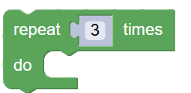
- Choose the “if/do/else” block from Logic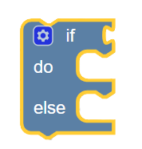 and place this block inside the “repeat 3 times” block (into the empty grey area).
- From Logic, drag the “= (equals)” block and drop it in the hexagonal slot of the if. Then, go to variables → Make a Variable → name it “answerCorrect”. From Variables, drag the answerCorrect block and place it on the left side of “=” . From Logic, drag the “true” block and place it on the right side of “=”. Inside the do part of the if block, drag print text from the Text tab and type:" ✅ Correct! (Green LED + Short Beep)" Inside the else part; From Text, drag another print text → type"❌ Wrong! (Red LED + Long Beep)" The blocks should be seen as:
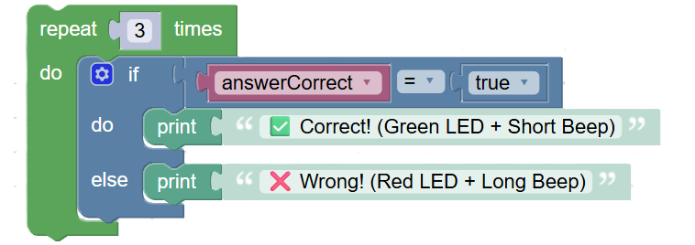
- Finally, outside of the repeat/do block, drag one more print text block from Text and type "🏁 Finished! Well done!"
- Your blocks will be seen as :
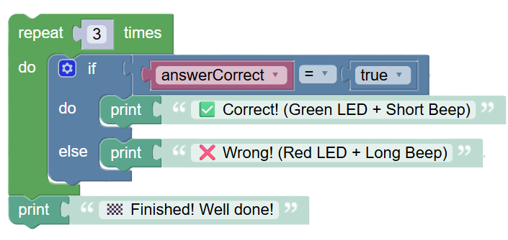
- Now, run your project.

Answer these questions:
Which probability question felt easiest? Why?
How did FOSSBot’s color and sound feedback help you notice your learning progress?

