SCENARIO TITLE
Traces of Time: Artists of the Paleolithic.
SUBJECT
Integrated STEAM Education

1. SCENARIO IDENTIFICATION
1.1 Scenario Title
Traces of Time: Artists of the Paleolithic
1.2 Target Age group
6th grade of Primary Education and 1st grade of Compulsory Secondary Education (ESO), adaptable to higher levels.
Curriculum: Primary Education and ESO..
Thematic Area: Natural Sciences, Social Sciences, Technology, Engineering, Visual Arts
Topics/Subtopics: STEAM, computational thinking.

1.3 Estimated Duration
50 minutes
1.4 Subject Areas Involved
STEAM disciplines (Science, Technology, Engineering, Arts, and Mathematics)
1.5 Prerequisite Knowledge
- Students should have previous familiarity with a programming environment.
- Possess basic computational skills.
1.6 Purpose of the Scenario
    - Lerarning Objectives / Outcomes
Students will:
- Identify and apply the properties of natural materials such as pigments, clay, leaves, and flowers, recognizing their use in painting and engraving techniques.
- Observe and analyze the physical changes that occur when manipulating natural materials, such as mixing pigments, applying paint, and using blowing techniques.
- Recognize the relationship between Paleolithic societies and the resources in their environment, understanding how the surroundings influenced their artistic and cultural expressions.
- Program the FOSSbot robot using the visual programming language Blockly to reproduce symbols and planned paths, developing basic computational thinking.
- Make technical adjustments to the robot’s design, ensuring precise interaction between the robot, the strokes, and the tools.
- Experiment with artistic techniques from rock art (blowing, stamping, and engraving) and create symbols inspired by the Paleolithic, integrating creativity with technology.

    - Teaching Objectives:
The educator aims to:
- Promote a transdisciplinary approach to learning, integrating knowledge and skills from various curricular areas through meaningful and contextualized experiences.
- Develop key 21st-century competencies such as computational thinking, scientific and technological literacy, heritage awareness, creativity, personal autonomy, and teamwork.
- Foster peer collaboration through joint problem-solving and role distribution, encouraging effective communication, shared decision-making, and respect for group ideas.
- Apply active methodologies such as Project-Based Learning (PBL) and Challenge-Based Learning (CBL) to solve real-world problems through collaborative design, research, and experimentation.
- Use educational robotics as a pedagogical tool to transform the teaching-learning process from an integrated, critical, and holistic STEAM perspective.

2. LESSON PLAN DEVELOPMENT
This lesson is based on a transdisciplinary approach that facilitates the coherent and meaningful integration of knowledge from various curricular areas, fostering a holistic view of learning.
The sequence of activities is designed following the Project-Based Learning (PBL) methodology, organized around a central thematic focus of great relevance: the Atapuerca archaeological site. This focus serves as an integrative and motivating context, generating multiple interconnected challenges that students must address collaboratively, thereby promoting teamwork and the collective construction of knowledge.
At the same time, the Challenge-Based Learning (CBL) strategy is incorporated, as the session presents a specific problem with practical applications aimed at stimulating the development of key competencies such as critical thinking, creativity, research skills, and interdisciplinary knowledge transfer.
The challenges have been designed to support the implementation of an integrated STEAM approach, where the FOSSbot robot becomes an essential mediating tool to facilitate a more dynamic and engaging interconnection of content.
- Contents:
Table 1. Relationship of content by disciplinary area
Disciplinary Area | Content
Natural Sciences | - Properties and uses of natural materials.- Physical processes involved in blowing techniques, paint application, and physical changes when manipulating materials.
Social Sciences | - Relationship between Paleolithic societies and natural resources in their environment.
Technology | - Basic programming using visual language (Blockly) to control the FOSSbot robot.- Use of sensors (color and infrared) for the robot’s interaction with drawings.- Application of current technologies to recreate ancient forms of expression.
Engineering | - Design and planning of trajectories to draw figures using a robot.- Robot adjustments for tool handling.
Arts | - Rock art techniques: pigment blowing, stamping with natural elements, and engraving.- Exploration and creation of Paleolithic symbols (hands, animals, spirals).

2.1 Description of Teaching and Learning Activities
In this lesson, students will explore rock art from Paleolithic societies through an experience that combines historical research, artistic experimentation, and educational robotics.
Materials:
- Simulated setting with Paleolithic symbols
- Large brown paper
- Tempera paints or natural pigments
- Straws for blowing technique
- Color sensor for the FOSSbot
- Leaves and flowers
Activiity 1
Building on the previous lesson, students are already familiar with the symbolism of rock art, its possible meanings, and the expressive, ritual, and communicative dimensions of these representations.
In this lesson, students will experiment directly with the materials and techniques of rock art. Large paper is placed on the classroom wall to simulate a cave, where each student practices the blowing technique using straws or reeds and diluted natural pigments. They also use natural elements such as leaves or flowers to create prints with paint and rollers, and engrave on stone or clay using styluses, emulating traditional rock art methods.
Activity 2
In this activity, students program the FOSSbot robot to replicate some of the symbols studied. Using the “marker holder” accessory, which allows the robot to hold a marker, and the visual programming tool Blockly, students plan trajectories to draw figures such as hands, spirals, or stylized animals.
This activity has a symbolic and expressive purpose: by programming the robot to recreate rock art, students develop computational thinking while exploring art as a system of cultural coding. The FOSSbot thus serves as a bridge between contemporary technology and ancient forms of expression, creating a transdisciplinary learning experience.
Activity 3
To conclude, on a large piece of cardboard, students draw a representative symbol. Then, using the robot’s infrared sensors, the challenge is for the FOSSbot to follow the drawn contour, reinforcing the connection between artistic creativity and technology.
2.2 Worksheets
Activity2
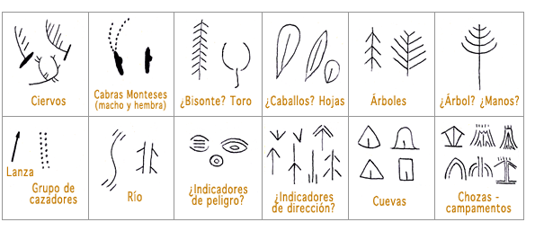

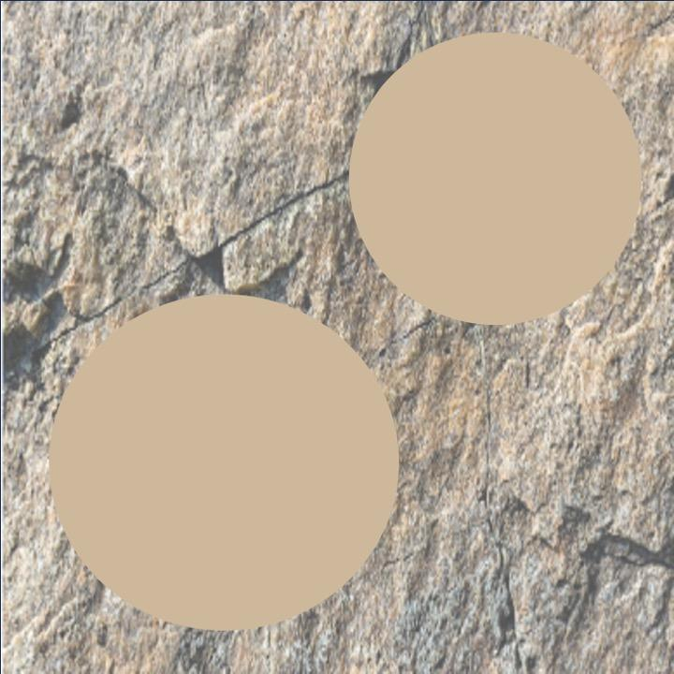

Figure 2. Example of a simulated setting for symbol representation using the FOSSbot robot.
Activiity 3
Knowledge assessment activities
Table 2. Student assessment rubric, designed to evaluate the student’s performance during the lesson.
Evaluation Criteria | Excellent | Good | Acceptable | Insufficient
Active participation and teamwork | Collaborates actively, respects and helps the group. Roles are balanced and well-defined | Good collaboration and participation, though roles are not always well-defined | Occasional participation. Some difficulties in task distribution | Little or no participation and collaboration, with clear disorganization
Planning | Activities perfectly structured, objectives clear and coherent | Activities well-structured, objectives adequate | Activities with clear objectives but lacking defined structure | Activities without defined objectives and lacking clear structure
Implementation | Activities carried out with excellent time management and class dynamics | Activities carried out correctly, with some issues in timing or dynamics | Activities carried out efficiently, but with notable problems | Activities carried out poorly, not meeting objectives
Use of FOSSbot | Students program and perform activities with FOSSbot autonomously | Students program and perform activities but need guidance | Students have difficulties programming FOSSbot | Students cannot program FOSSbot and require constant support
Innovation and creativity | Impeccable use of FOSSbot, integrated effectively and creatively | Adequate use of
Table 3. Relationship between the key curriculum competences and the observable learning evidence in the challenges developed during the lesson.
Key Competence | Observable Evidence
Mathematical competence and basic competence in science and technology | Use of coordinates, sensors, analysis of archaeological remains, classification of objects
Competence in cultural awareness and expression | Representation of objects to scale
Digital competence | Block-based programming (Blockly), use of the FOSSbot robot, solving technical problems

