SCENARIO TITLE
Rites and Beliefs: The Mysteries of the Past
SUBJECT
Integrated STEAM Education

1. SCENARIO IDENTIFICATION
1.1 Scenario Title
Rites and Beliefs: The Mysteries of the Past
1.2 Target Age group
6th grade of Primary Education and 1st grade of Compulsory Secondary Education (ESO), adaptable to higher levels.
Curriculum: Primary Education and ESO..
Thematic Area: Social Sciences, Technology, Engineering, Visual Arts
Topics/Subtopics: STEAM, computational thinking.
1.3 Estimated Duration
50 minutes
1.4 Subject Areas Involved
STEAM disciplines (Science, Technology, Engineering, Arts, and Mathematics)
1.5 Prerequisite Knowledge
- Students should have previous familiarity with a programming environment.
- Possess basic computational skills.
1.6 Purpose of the Scenario
    - Lerarning Objectives / Outcomes
Students will:
- Recognize and interpret cultural, symbolic, and ritual elements of prehistoric societies through the analysis of objects and material evidence.
- Critically differentiate between prehistoric and anachronistic objects, justifying the classification through observation, comparison, and historical reasoning.
- Program and control the FOSSbot robot to detect, respond, and navigate autonomously using distance sensors.
- Apply technological and digital fabrication tools, such as 3D printing, to design and produce replicas or functional objects related to the activity.
- Design, build, and improve prototypes or objects through basic engineering processes, solving technical problems arising from their use in the simulated environment.
- Create and present artistic and visual productions that represent prehistoric objects and clearly communicate the project’s findings and conclusions.
    - Teaching Objectives:
The educator aims to:
- Promote a transdisciplinary approach to learning, integrating knowledge and skills from various curricular areas through meaningful and contextualized experiences.
- Develop key 21st-century competencies such as computational thinking, scientific and technological literacy, heritage awareness, creativity, personal autonomy, and teamwork.
- Foster peer collaboration through joint problem-solving and role distribution, encouraging effective communication, shared decision-making, and respect for group ideas.
- Apply active methodologies such as Project-Based Learning (PBL) and Challenge-Based Learning (CBL) to solve real-world problems through collaborative design, research, and experimentation.
- Use educational robotics as a pedagogical tool to transform the teaching-learning process from an integrated, critical, and holistic STEAM perspective.
2. LESSON PLAN DEVELOPMENT
This lesson is based on a transdisciplinary approach that facilitates the coherent and meaningful integration of knowledge across different curricular areas, fostering a holistic perspective on learning.
The sequence of activities is designed following the Project-Based Learning (PBL) methodology, organized around a central thematic focus of great relevance: the Atapuerca archaeological site. This focus serves as an integrative and motivating context, generating multiple interconnected challenges that students must address collaboratively, thereby promoting teamwork and the collective construction of knowledge.
At the same time, the Challenge-Based Learning (CBL) strategy is incorporated, as the session presents a specific problem with practical applications, aimed at stimulating the development of key competencies such as critical thinking, creativity, research skills, and interdisciplinary knowledge transfer.
The challenges have been designed to support the implementation of an integrated STEAM approach, where the FOSSbot robot becomes an essential mediating tool to facilitate a more dynamic and engaging interconnection of content.

- Contents:
Table 1. Relationship of content by disciplinary area
Disciplinary Area | Content
Social Sciences | - Recognition of cultural and ritual elements of prehistoric societies.- Differentiation between prehistoric and anachronistic objects through critical analysis.- Historical interpretation based on material evidence.
Technology | - Basic programming of the FOSSbot robot to detect and respond to objects.- Use and understanding of ultrasonic or infrared sensors.- Application of digital tools to produce replicas (e.g., 3D printing).
Engineering | - Design and creation of objects or prototypes using various materials and techniques.- Solving technical problems during the robot’s autonomous navigation.- A

2.1 Description of Teaching and Learning Activities
This session focuses on the ritual practices of prehistoric societies through the analysis of objects found in funerary contexts.
Materials:
- Large-scale printed simulated setting representing a funerary space
- Miniatures or replicas of prehistoric funerary objects
- Anachronistic objects to create confusion (modern toys, books)
- Objects created using 3D printing
- Template or model simulating a funerary space
- Distance sensor (ultrasonic or infrared) for the FOSSbot robot
Activity1
The challenge of this lesson is presented as a simulation activity in which students must identify, classify, and justify the symbolic or ritual value of various objects arranged in a setting representing a funerary space.
The objects can be used directly if available, or created by students in a prior session using fabrication techniques such as 3D printing or traditional materials (EVA foam, clay, cardboard). Typical prehistoric objects (amulets, vessels, bones, tools) are included, as well as anachronistic elements (books, mobile phones, toys) to provoke debate and critical analysis of their relevance.
Activity 2
Students work in collaborative teams and must program the FOSSbot robot to navigate autonomously through the simulated funerary space. Using its ultrasonic sensor, the robot detects objects when they are within a set distance (e.g., 10 cm). Upon detecting an object, the robot automatically stops and emits an alert signal (light or sound).
Activity 3
After detecting an object, the group analyzes its possible ritual value and whether it belongs to the prehistoric period. If deemed appropriate, the object is placed on the robot, which transports it to the classification area.
Each team completes an analysis sheet for each object, including: name, description, hypothesis about its symbolic or utilitarian function, approximate period, and justification for its inclusion or exclusion. Finally, the groups present their conclusions to the rest of the class, followed by a brief collaborative debate comparing different viewpoints with supporting arguments.
Activi
Activity 4
This activity consists of a final presentation in which students, organized in cooperative groups, present their products and findings. This session evaluates the learning outcomes achieved, consolidates overall understanding of the project, and promotes metacognition as well as recognition of collaborative effort.
Each group, composed of 4 to 5 members, prepares a brief presentation lasting between 5 and 7 minutes, summarizing the findings from the funerary space. They will base their presentation on a worksheet analyzing each object, its historical period, and justification.
Finally, each student will individually complete a more general worksheet on Prehistory.
2.2 Worksheets
Actividad 1
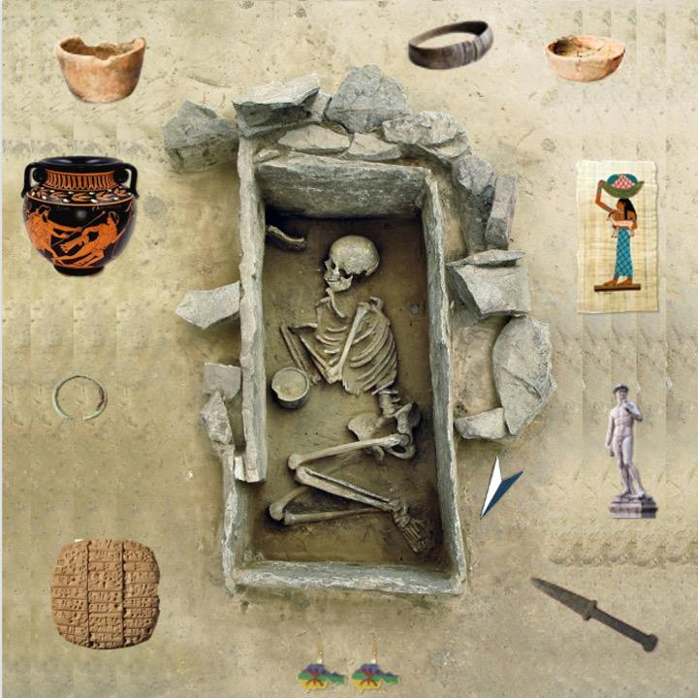
igure 1. Large-scale printed simulated setting representing a funerary space.
Activity 2
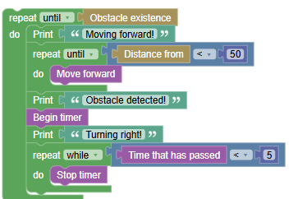
Figure 2. Example of FOSSbot programming to stop in front of an object and turn on a light.

Activity 4
Knowledge assessment activities
Object | Historical Period | Justification
Greek/Corinthian Helmet | Ancient Age | Belonged to Greek soldiers between the 7th and 4th centuries BCE.
Round Metal Helmet | Middle Ages | Typical protection used in medieval warfare.
Brown and Green Bead Necklace | Prehistory (Neolithic) | Common decorative craft item in early agricultural cultures.
Long Bone (Femur) | Prehistory (Paleolithic or Neolithic) | Possibly used as a tool or in funerary rituals.
Stone Clubs | Prehistory (Paleolithic) | Typical tool of hunter-gatherer societies.
Clay Vessel | Prehistory (Neolithic) | Associated with the beginnings of pottery and sedentary life.
Books | Modern or Contemporary Age | Could belong to either period due to book materials, as printing already existed.
Shotgun | Modern or Contemporary Age | Firearm developed after gunpowder, from the 17th century onward.
Flint Knife | Prehistory (Paleolithic/Neolithic) | Typical tool of hunter-gatherer societies.
Telephone | Contemporary Age | A recently created object.

Figure 3. Example of a worksheet on funerary findings.

Table 2. Student assessment rubric, designed to evaluate the student’s performance during the lesson.
Evaluation Criteria | Excellent | Good | Acceptable | Insufficient
Active participation and teamwork | Collaborates actively, respects and helps the group. Roles are balanced and well-defined | Good collaboration and participation, though roles are not always well-defined | Occasional participation. Some difficulties in task distribution | Little or no participation and collaboration, with clear disorganization
Planning | Activities perfectly structured, objectives clear and coherent | Activities well-structured, objectives adequate | Activities with clear objectives but lacking defined structure | Activities without defined objectives and lacking clear structure
Implementation | Activities carried out with excellent time management and class dynamics | Activities carried out correctly, with some issues in timing or dynamics | Activities carried out efficiently, but with notable problems | Activities carried out poorly, not meeting objectives
Use of FOSSbot | Students program and perform activities with FOSSbot autonomously | Students program and perform activities but need guidance | Students have difficulties programming FOSSbot | Students cannot program FOSSbot and require constant support
Innovation and creativity | Impeccable use of FOSSbot, integrated effectively and creatively | Adequate use of
Table 3. Relationship between the key curriculum competences and the observable learning evidence in the challenges developed during the lesson.
Key Competence | Observable Evidence
Mathematical competence and basic competence in science and technology | Use of coordinates, sensors, analysis of archaeological remains, classification of objects
Competence in cultural awareness and expression | Representation of objects to scale
Digital competence | Block-based programming (Blockly), use of the FOSSbot robot, solving technical problems

