SCENARIO TITLE
We are archaeologists. The remains of a prehistoric site.

SUBJECT
Integrated STEAM Education

1. SCENARIO IDENTIFICATION
1.1 Scenario Title
We are archaeologists. The remains of a prehistoric site.
1.2 Target Age group
6th grade of Primary Education and 1st grade of Compulsory Secondary Education (ESO), adaptable to higher levels.
Curriculum: Primary Education and ESO.
Thematic area: Natural Sciences, Social Sciences, Technology, Engineering, Visual Arts, Mathematics.
Topics/Subtopics: STEAM, computational thinking.

1.3 Estimated Duration
50 minutes
1.4 Subject Areas Involved
STEAM disciplines (Science, Technology, Engineering, Arts, and Mathematics)
1.5 Prerequisite Knowledge
- Students should have previous familiarity with a programming environment.
- Possess basic computational skills.
1.6 Purpose of the Scenario
1.6.1 Objetivos / Resultados de Aprendizaje
Students will be able to:
- Observe, classify, and analyze simulated archaeological evidence, applying basic principles of human evolution and fossilization processes.
- Organize and record archaeological data, understanding the social structure of prehistoric human groups and valuing historical heritage.
- Program the FOSSbot robot using Blockly, applying sensors and algorithms so it can autonomously detect and transport findings.
- Design excavation routes and scenarios, evaluating obstacles and optimizing the robot’s path through engineering thinking.
- Represent the location of findings using Cartesian coordinates, calculate distances and trajectories, and solve problems involving spatial orientation.
- Graphically represent the findings, respecting proportions, color, and shadows to facilitate the visual and scientific interpretation of objects.
    - Teaching Objectives:
The educator aims to:
- Promote a transdisciplinary approach to learning, integrating knowledge and skills from various curricular areas through meaningful and contextualized experiences.
- Develop key 21st-century competencies such as computational thinking, scientific and technological literacy, heritage awareness, creativity, personal autonomy, and teamwork.
- Foster peer collaboration through joint problem-solving and role distribution, encouraging effective communication, shared decision-making, and respect for group ideas.
- Apply active methodologies such as Project-Based Learning (PBL) and Challenge-Based Learning (CBL) to solve real-world problems through collaborative design, research, and experimentation.
- Use educational robotics as a pedagogical tool to transform the teaching-learning process from an integrated, critical, and holistic STEAM perspective.

2. DESARROLLO DEL PLAN DE LECCIÓN
This lesson is based on a transdisciplinary approach that facilitates the coherent and meaningful integration of knowledge from various curricular areas, fostering a holistic view of learning.
The sequence of activities is designed following the Project-Based Learning (PBL) methodology, organized around a central thematic axis of great relevance: the archaeological site of Atapuerca. This axis serves as an integrating and motivating context from which multiple interrelated challenges emerge that students must collaboratively address, thus promoting teamwork and the collective construction of knowledge.
At the same time, the Challenge-Based Learning (CBL) strategy is incorporated, as the session presents a specific problem with practical applications, aimed at stimulating the development of key competencies such as critical thinking, creativity, research skills, and the interdisciplinary transfer of knowledge.
The challenge has been designed to support the implementation of an integrated STEAM approach, where the FOSSbot robot becomes an essential mediating tool to facilitate a more dynamic and motivating interconnection of content.
- Content:
Table 1. Relationship of content by disciplinary area
Disciplinary Area | Content
Natural Sciences | - - Study of fossil remains, materials, and archaeological evidence.- Basic principles of human evolution and fossilization processes.- Observation, classification, and analysis of simulated archaeological evidence.- Development of scientific and research skills.
Social Sciences | - - Classification and organization of archaeological data.- Understanding the social organization of prehistoric human groups.- Critical appreciation of historical and archaeological heritage.
Technology | - - Programming the FOSSbot robot using visual platforms such as Blockly.- Use of motion and infrared sensors.- Route design and movement planning.- Development of algorithms for automated decision-making.
Engineering | - - Representation and design of an archaeological excavation scenario.- Evaluation of challenges in the simulated terrain and decision-making to avoid or overcome them.- Optimization of the robot’s routes: minimizing time, avoiding collisions, maximizing findings.- Application of engineering thinking to solve the challenges posed in the activity.
Arts | - - Graphic representation of collected archaeological data while maintaining proportion, color accuracy, and shading.
Mathematics | - - Representation using Cartesian coordinates or grids to record the precise location of findings.- Calculation of distances and trajectories between points on the board.- Spatial interpretation of the scenario: orientation (north, south, east, west), and robot turns (90º, 180º).- Measurement and comparison of lengths and proportions of discovered objects.- Solving spatial problems to plan the robot’s most efficient route.

  - Description of Teaching and Learning Activities
Students are introduced to archaeological fieldwork through a simulated classroom experience.
Materials:
- Simulated scenario with a large-scale grid
- Cards for recording coordinates and findings
- Replicas of fictional archaeological remains made of EVA foam, cardboard, or 3D printing (stones, bones, tools, weapons)
Actividad 1
The first activity consists of replicating an archaeological excavation using a simulated scenario compatible with the FOSSbot robot, which is used to locate, detect, and transport simulated objects representing different types of prehistoric findings.
The activity is designed as a collaborative challenge based on Challenge-Based Learning (CBL), where students must program the FOSSbot to move across the grid and detect archaeological remains distributed throughout the workspace. Using ultrasonic sensors, the robot automatically stops when it detects an object at a configurable distance of less than 10 cm and emits a sound signal to indicate the finding.
To program the robot, students use the visual platform Blockly, which facilitates structuring movements through block-based programming. They also have access to simulated scenarios to practice movements before running them with the physical robot. Figure 2 illustrates a programmed sequence in Blockly for the route.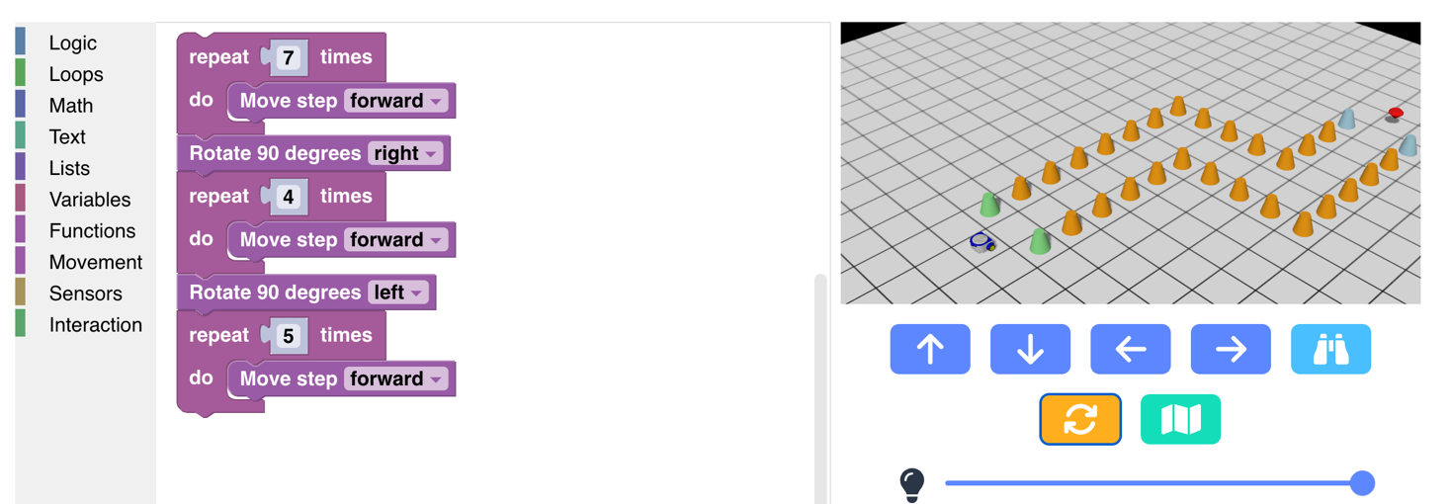
Figure 2. Example of programming with Blockly in a simulated environment
Activity 2
Once the object has been detected, students can pick it up manually or drag it if the robot’s design allows it, and then move it to the classification area prepared in the classroom. Each group keeps a systematic record of the findings by noting the corresponding coordinates on the template. The simulated objects include representations of long bones, lithic tools, ceramic fragments, and coprolites, produced using 3D printing or, alternatively, with materials such as EVA foam, cardboard, or clay.
Once collected, these recovered objects are depicted while attempting to ensure correct proportions, appropriate color, and proper representation of shadows.
Activity 3
Each group completes a test to assess the knowledge learned during the lesson.
2.2 Worksheets
Activity 1
Figure 1 shows an example of what the simulated scenario might look like.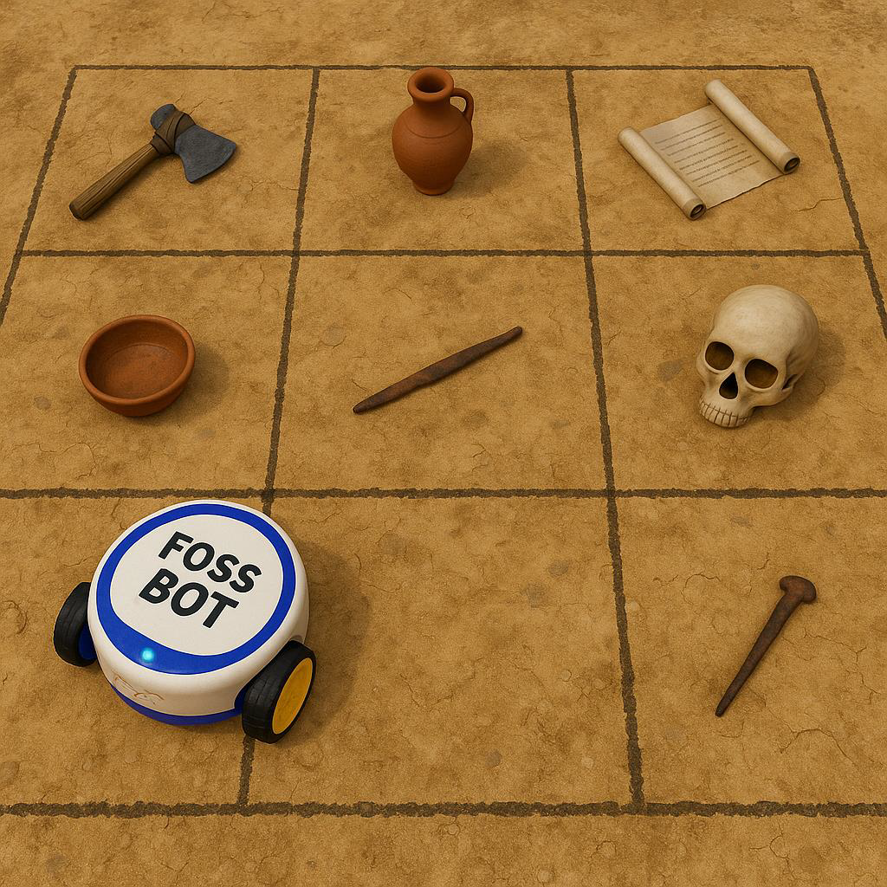
Figure 1. Example of a possible simulated scenario.
Activity 2
Figure 3 is shown as an example of FOSSbot programming to stop in front of an obstacle and turn on a light.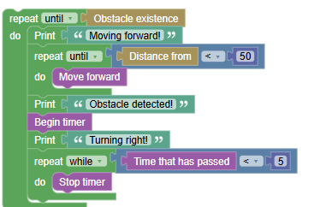
Figure 3. Example of FOSSbot programming to stop when encountering an obstacle and turn on a light.
Actividad 3
Knowledge assessment activities
- What does the FOSSBot’s ultrasonic sensor detect?
a) Color changes
b) Objects close by at a certain distance
c) Ambient temperature
- What type of remains are used as evidence in the simulated excavation?
a) Real organic remains
b) Simulated bones, lithic tools, and ceramics
c) Modern metal objects
- What is the Blockly platform used for in this unit?
a) To create 3D models
b) To program the robot using visual blocks
c) To edit videos
- What happens when the FOSSBot detects an object less than 10 cm away?
a) It accelerates to avoid it
b) It stops and emits a sound signal
c) It turns on a fan
- Which mathematical tool is used to record the position of the findings?
a) Cartesian coordinates
b) Equivalent fractions
c) Repeated addition
- To represent the exact location of a finding on the excavation grid, you use:
a) Cartesian coordinates
b) Heat maps
c) Bar charts
- If the robot must turn 90º to the right and then move forward 2 units, which mathematical concept is being applied?
a) Fraction addition
b) Angles and spatial orientation
c) Multiplication of coordinates
- When graphically representing a finding, it is important to:
a) Make a quick sketch even if it is not clear, just to know where it was located.
b) Try to maintain correct proportion, color, and shading so it can be identified later.
c) Only draw outlines to save time.
ANSWERS
1 – b
2 – b
3 – b
4 – b
5 – a
6 – a
7 – b
8 – b

Table 2. Student assessment rubric, designed to evaluate the student’s performance during the lesson.
Evaluation Criteria | Excellent | Good | Acceptable | Insufficient
Active participation and teamwork | Collaborates actively, respects and helps the group. Roles are balanced and well-defined | Good collaboration and participation, though roles are not always well-defined | Occasional participation. Some difficulties in task distribution | Little or no participation and collaboration, with clear disorganization
Planning | Activities perfectly structured, objectives clear and coherent | Activities well-structured, objectives adequate | Activities with clear objectives but lacking defined structure | Activities without defined objectives and lacking clear structure
Implementation | Activities carried out with excellent time management and class dynamics | Activities carried out correctly, with some issues in timing or dynamics | Activities carried out efficiently, but with notable problems | Activities carried out poorly, not meeting objectives
Use of FOSSbot | Students program and perform activities with FOSSbot autonomously | Students program and perform activities but need guidance | Students have difficulties programming FOSSbot | Students cannot program FOSSbot and require constant support
Innovation and creativity | Impeccable use of FOSSbot, integrated effectively and creatively | Adequate use of
Table 3. Relationship between the key curriculum competences and the observable learning evidence in the challenges developed during the lesson.
Key Competence | Observable Evidence
Mathematical competence and basic competence in science and technology | Use of coordinates, sensors, analysis of archaeological remains, classification of objects
Competence in cultural awareness and expression | Representation of objects to scale
Digital competence | Block-based programming (Blockly), use of the FOSSbot robot, solving technical problems

