SCENARIO TITLE
Time-controlled movement with colours

SUBJECT
Programming / Creative Robotics / Natural Sciences

1. SCENARIO IDENTIFICATION
1.1 Scenario Title
Time-controlled movement with colours

1.2 Target Age Group
13-14 years old
Curriculum: Lower levels of lower secondary
Thematic Area: Algorithms and computer systems programming
Topics/Subtopics: Problem solving with programming tools. Robot programming and automation.
Expected Learning Outcomes:
Students are expected to learn to:
- Use a timer to control the movement of a robot.
- Create sequences of commands with different durations.
- Correlate direction of movement with time intervals.
- Use LED colours as a visual feedback mechanism.
- Monitor and interpret the flow of a program in real time.

1.3 Estimated Duration
45 minutes

1.4 Subject Areas Involved
Scenario topic:
Use time control to create a programmed sequence of robot movements, where each movement is associated with a specific colour and duration.
Subjects:
- Information Technology: conditional loops, serial execution, timers.
- Natural Sciences: motion, time, displacement.
- Mathematics: comparison of time intervals.
- Art/Creativity: linking motion with colour.

1.5 Prerequisite Knowledge
Students should:
- Have basic familiarity with visual programming environments.
- Understand simple robot movement commands.
- Understand the concept of time as a measurable quantity.
- Be able to work in small groups (3–5 people).

1.6 Purpose of the Scenario
The scenario aims to understand how time can be used as a key mechanism for controlling a robot's behaviour. Students observe how a sequence of movements is performed for different durations and how colours help to understand the flow of the program.
1.6.1 Learning Objectives/Outcomes
Upon completion of the educational scenario, students will be able to:
- Execute a program with time-controlled commands.
- Distinguish between time control and distance or sensor control.
- Describe the sequence of execution of a program.
- Associate LED colours with specific actions.

2. LESSON PLAN DEVELOPMENT
2.1 Description of Teaching and Learning Activities
Teaching is based on experiential learning. Students work in small groups (3–5 people) and program the FOSSBot to perform a specific "choreography" of movements, controlled exclusively by time.
The flow of activities includes:
Activity 1: Discussion on how a robot's movement can be controlled based on time.
Activity 2: Predicting the robot's behaviour when time durations change.
Activity 3: Running a ready-made program and observing the sequence of movements.
Activity 4: Analysing the relationship between time, movement, and colour.
Activity 5: Modifying time parameters and observing differences.
The educational process is enhanced by the integration of gamification and interactive assessment elements through the H5P platform.
In order to implement the activities, the FOSSBot must first be synchronized with the local Wi-Fi network.
2.2 Worksheet
Activity 1
Students respond: How can time determine the duration of a movement?

Activity 2
Students predict what will happen when the robot:
- moves for a shorter time,
- moves for a longer time.

Activity 3
Open FOSSBot and connect to the local network.
Go to: http://fossbot-000.local:8081/
Download the Timed Movement with Colors project and run it.
Code (block–by–block):
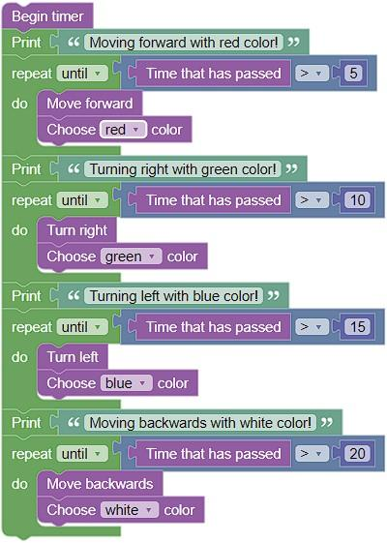

What do you notice?
…………………………………………………………
…………………………………………………………

Activity 4
The students observe the program running and record the relationship between time, movement, and LED colour.
- Which movement corresponds to each colour.
- How long each action lasts.
They complete the following table:
Execution order | Robot movement | LED color | Duration (time units)
1 | Move forward | Red
2 | Turn right | Green
3 | Turn left | Blue
4 | Move backward | White

Activity 5
Using the same code:
- Change the time values (e.g., 5 → 8, 10 → 12).
- Observe how the robot's overall movement changes.
- Try a different sequence of movements.
Answer:
- Which change has the greatest effect on the robot's behaviour?
- How do the colours help you understand the flow?

