SCENARIO TITLE
Edge detection and safe robot navigation

SUBJECT
Programming / Robotics / Engineering

1. SCENARIO IDENTIFICATION
1.1 Scenario Title
Edge detection and safe robot navigation

1.2 Target Age Group
14-15 years old
Curriculum: Upper levels of lower secondary
Thematic Area: Algorithms and computer systems programming / Robotics
Topics/Subtopics: Problem solving with programming tools. Robot programming and automation.
Expected Learning Outcomes:
Students are expected to learn to:
- Use FOSSBot floor sensors.
- Combine multiple conditions with if – else if structures.
- Program risk avoidance behaviour.
- Understand how robots make safety decisions.
- Relate sensors to real-world safety systems.

1.3 Estimated Duration
45 minutes

1.4 Subject Areas Involved
Scenario topic:
Use of floor sensors to detect edges and automatically prevent a robot from falling.
Subjects:
- Information Technology: conditions, logical operators, selection structures.
- Natural Sciences: equilibrium, motion, stability.
- Technology/Engineering: robot safety systems.

1.5 Prerequisite Knowledge
Students should:
- Be familiar with basic selection structures (if – else).
- Be familiar with sensors.
- Have used basic robot movement commands.
- Be able to work in small groups (3–5 people).

1.6 Purpose of the Scenario
The scenario aims to show how a robot can detect dangerous conditions and adjust its behaviour to avoid falls. Students understand the importance of safety in the design of autonomous systems.
1.6.1 Learning Objectives/Outcomes
Upon completion of the educational scenario, students will be able to:
- Read values from two floor sensors.
- Combine conditions with logical AND.
- Describe how the robot reacts to different hazard scenarios.
- Explain why backing up and turning increase safety.

2. LESSON PLAN DEVELOPMENT
2.1 Description of Teaching and Learning Activities
Teaching is based on experiential learning. Students work in groups and observe how FOSSBot avoids falling off edges.
The flow of activities includes:
Activity 1: Discussion on how a robot can "understand" that there is an edge.
Activity 2: Predicting the robot's behaviour when the ground disappears under a sensor.
Activity 3: Running a ready-made program and observing.
Activity 4: Analysing different scenarios (right, left, forward).
Activity 5: Modifying parameters (backward distance or turning angle) and observing.

2.2 Worksheet
Activity 1
Students describe what "edge" means for a robot and how it can be detected.

Activity 2
Fill in the following table:
Left sensor | Right sensor | Expected action

Activity 3
Log in to FOSSBot or CoppeliaSim and load the sens6_edge_detection stage.
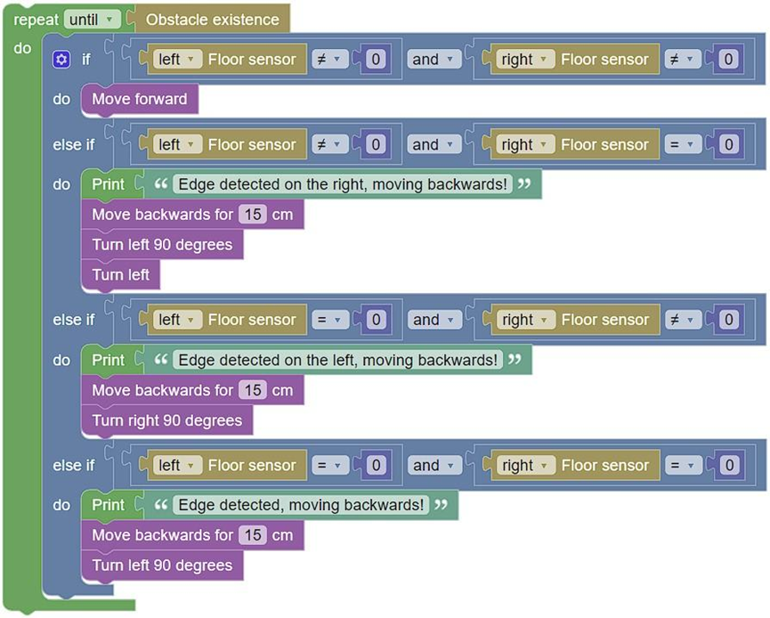

What do you notice?
…………………………………………………………
…………………………………………………………

Activity 4
Students explain why each situation requires a different response.

Activity 5
Using the same code:
- Change the backward distance from 15 cm to 20 cm.
- Change the turning angle from 90° to 45°.
- Observe whether the robot effectively avoids falling.
Students should answer:
- Which setting is safer?
- How is navigation affected?

