SCENARIO TITLE
Measuring velocity

SUBJECT
Programming – Natural Sciences

1. SCENARIO IDENTIFICATION
1.1 Scenario Title
Measuring velocity with an educational robot

1.2 Target Age Group
14-15 years old
Curriculum: Upper levels of lower secondary
Thematic Area: Algorithms and computer systems programming
Topics/Subtopics: Problem solving with programming tools. Robot programming and automation.
Expected Learning Outcomes:
Students are expected to learn to:
- Use FOSSBot to measure physical quantities.
- Connect physics concepts (distance, time, speed) with algorithmic processes.
- Use a timer within a program.
- Apply a mathematical formula within the code.
- Interpret numerical results produced by a robot.

1.3 Estimated Duration
45 minutes

1.4 Subject Areas Involved
Scenario topic:
Use of educational robotics to measure the speed of a moving body through controlled motion and timing.
Subjects:
- Information technology: algorithms, stopwatches, arithmetic operations, printing results.
- Natural sciences: motion, speed, time, distance.
- Mathematics: division, units of measurement (cm, s).

1.5 Prerequisite Knowledge
Students should:
- Have basic familiarity with visual programming environments such as Scratch.
- Understand basic programming concepts (loop structure and condition).
- Understand basic programming concepts.
- Know the formula for calculating speed.
- Have basic experience using FOSSBot.
- Be able to work in small groups (3–5 people).

1.6 Purpose of the Scenario
The scenario aims to link physics with programming through an experimental process. Students use FOSSBot as a measuring tool, record the time taken to travel a known distance, and calculate speed, understanding how a physical law can be implemented algorithmically.
1.6.1 Learning Objectives/Outcomes
Upon completion of the educational scenario, students will be able to:
- Run a program on FOSSBot.
- Use a timer within an algorithm.
- Calculate speed based on distance and time.
- Interpret measurement results.
- Connect experimental data with theoretical concepts.

2. LESSON PLAN DEVELOPMENT
2.1 Description of Teaching and Learning Activities
Teaching is based on experiential and exploratory learning. Students work in small groups (3–5 people), using FOSSBot to conduct a simple speed measurement experiment.
The flow of activities includes:
Activity 1: Discussion of the concept of speed and the formula for calculating it.
Activity 2: Predicting the speed of the robot before performing the experiment.
Activity 3: Running a ready-made program on FOSSBot and observing its behaviour.
Activity 4: Analysing how speed is calculated within the program.
Activity 5: Discussing the results and comparing between groups.

2.2 Worksheet
Activity 1
Students are asked to write down the formula for speed and explain in words what each variable represents.

Activity 2
The students predict what the robot's speed will be at a distance of 30 cm.

Activity 3
Open FOSSBot and connect to the local network.
Go to: http://fossbot-000.local:8081
Download the Measuring Velocity project.
Press Edit and Run.
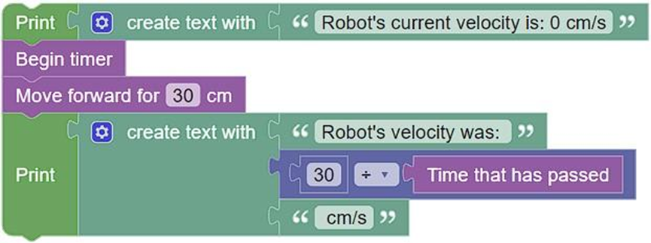

What do you notice?
…………………………………………………………
…………………………………………………………

Activity 4
Students record the time and calculated speed and discuss possible measurement errors.

Activity 5
Using the same code from Activity 3, students are asked to modify the program parameters and observe the changes in the robot's behaviour.
Specifically:
- Change the robot's movement distance from 30 cm to 50 cm.
- Run the program again and record:
  - the time measured,
  - the speed calculated.
- Repeat the process for a distance of 100 cm.
Then answer:
- How is the speed value affected when the distance increases?
- Do you notice any differences in the movement time?
- Are the results the same in each run?
The students discuss the results and find that, although the formula remains the same, the measurements may differ due to real conditions (battery, surface, friction).

