SCENARIO TITLE
Light control with light sensor

SUBJECT
Programming – Natural Sciences

1. SCENARIO IDENTIFICATION
1.1 Scenario Title
Light control with light sensor

1.2 Target Age Group
13-14 years old
Curriculum: Lower secondary
Thematic Area: Algorithms and computer systems programming
Topics/Subtopics: Problem solving with programming tools. Robot programming and automation.
Expected Learning Outcomes:
Students are expected to learn to:
- Use and program the FOSSBot light sensor.
- Design and implement algorithmic repetition structures (repeat while, repeat until, repeat times).
- Understand the use of conditions for decision-making by a robot.
- Connect environmental conditions (light/dark) with visual and kinetic behaviour.
- Interpret a robot's behaviour based on sensor data.

1.3 Estimated Duration
45 minutes

1.4 Subject Areas Involved
Scenario topic:
Use of educational robotics to detect light and dark conditions and automatically adjust a robot's behaviour.
Subjects:
- Computer science: algorithmic thinking, conditions, repetitions, sensors, automation.
- Natural sciences: light, darkness, light intensity, detection of environmental changes.

1.5 Prerequisite Knowledge
- Have basic familiarity with visual programming environments such as Scratch.
- Understand basic programming concepts (loop structure and condition).
- Know what a sensor is and how it is used.
- Have basic experience using FOSSBot.
- Be able to work in small groups (3–5 people).

1.6 Purpose of the Scenario
The scenario aims to understand how a light sensor can guide a robot's behaviour. Through the continuous alternation of light and darkness, students observe how the algorithm makes decisions and adapts to the environment.
Upon completion of the educational scenario, students will be able to:
- Connect the FOSSBot to the local network and run ready-made programs.
- Interpret the operation of the light sensor through the robot's behaviour.
- Distinguish between the use of different types of repetition in the same algorithm.
- Connect LED colours to system states (light/dark).
- Describe in words the flow of a condition-based program.

1.6.1 Learning Objectives/Outcomes
The scenario aims to:
- Promote experiential and exploratory learning.
- Develop algorithmic and computational thinking.
- Enhance understanding of the relationship between sensors and automation.
- Cultivate observation and reflection skills.

2. LESSON PLAN DEVELOPMENT
2.1 Description of Teaching and Learning Activities
Teaching is based on experiential and exploratory learning. Students work in small groups (3–5 people) and interact with FOSSBot, observing how it reacts to changes in lighting.
The flow of activities includes:
Activity 1
Students discuss when a space is considered dark or light and which everyday devices use light sensors.
Activity 2
Students predict how a robot could "understand" that it is in the dark and how it could indicate this.
Activity 3
Students connect to the FOSSBot via the local network.
On a computer connected to the same network, they open a browser (Chrome or Firefox) and go to the address:
http://fossbot-000.local:8081
Download and open the project:
Light Sensor Example – block code
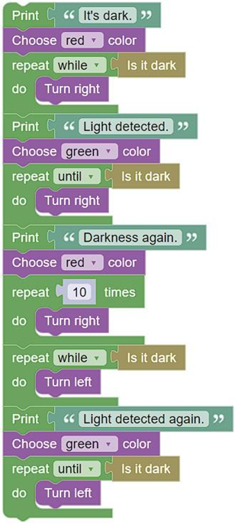
Students run the project.
What do you notice?
………………………………………………………………………………
………………………………………………………………………………
Activity 4
Students experiment with different lighting conditions (flashlight, sensor shading) and observe:
- when the LED colour changes,
- when the direction of movement changes,
- when a repetition ends or begins.

Activity 5
Students describe the program flow orally or in writing:
- what happens in the dark,
- what happens when light is detected,
- what is the role of each type of loop.

2.2 Worksheet
Activity 1
Students are asked to observe the space and identify when it is considered dark and when it is light. They then discuss in groups:
- How can a robot "understand" that it is dark?
- What role can a light sensor play in an automated system?
The answers are summarized on the worksheet.

Activity 2
Students correlate lighting situations with LED colors, as used in the robot code.
They complete the following table:
Environment Status | LED Colour | Interpretation
Dark | Red | Warning status
Light | Green | Normal operation status
Discuss why these specific colours are suitable for visual feedback.

Activity 3
Turn on the FOSSBot and wait a few seconds for it to connect to your local Wi-Fi network.
On a computer or laptop connected to the same network as the FOSSBot:
- Open the Chrome or Firefox browser.
- Go to: http://fossbot-000.local:8081/
- Download and open the Light Sensor Example project.
- Press Edit, then Run.
The students observe the robot's behaviour and answer:
What do you notice when:
- it is dark?
- light is detected?
- the direction of movement changes?

………………………………………………………………………………
………………………………………………………………………………

Activity 4
Students experiment with the light sensor:
- covering the sensor with their hand,
- illuminating it with a flashlight or lamp.
They record on a worksheet:
- which loop is activated each time,
- which message appears,
- which LED color lights up.
The goal is for them to understand that the sensor condition controls the flow of the program.

Activity 5
Students are asked to describe the program's operation in words, answering:
- When is the repeat while loop used?
- When is the repeat until loop used?
- Why is there a repeat 10 times loop?
- How does the robot "decide" what to do?
The activity concludes with a brief reflection on how similar logic is used in real-world systems (e.g., automatic lights).

