SCENARIO TITLE
Navigation through Traffic

SUBJECT
Programming – Road Behaviour

1. SCENARIO IDENTIFICATION
1.1 Scenario Title
Navigation through Traffic

1.2 Target Age Group
13-16 years old
Curriculum: Lower secondary / first year of upper secondary
Thematic Area: Computational systems, digital devices, networks
Topics/Subtopics: Automation and robotic systems – connecting computers to the physical world
Expected Learning Outcomes:
Students will be able to:
• Select and connect sensor-equipped devices and/or robotic systems to computers in order to control them or collect data.
• Program an application that controls a pre-assembled robotic or automation system using simple sensors and actuators, within the framework of a learning project.
• Design and program educational robotic and automation systems using physical computing to conduct experiments or creative learning projects involving design and construction.
• Explain how the Ultrasonic sensor work, attempt to construct them, calibrate them, and control them using code on a computer.

1.3 Estimated Duration
30 minutes for lesson
15 minutes for assessment

1.4 Subject Areas Involved
Computer Science, Technology

1.5 Prerequisite Knowledge
Students should be familiar with a visual programming environment. They should be able to create and debug programs. They must understand the concepts of loops and conditional statements and have applied them in a visual programming setting.

1.6 Purpose of the Scenario
By the end of the lesson, students should have:
- become familiar with using the FOSSBot robot and programming environment
- program sensors in combination with other FOSSBot components
- developed problem-solving skills, adaptability, and the ability to use new programming and graphical environments through teamwork, collaboration, and creativity

1.6.1 Learning Objectives/Outcomes
Students will be able to:
- Operate the FOSSBot interface environment (connection, project input, and editing)
- Identify the basic functions and use of sensors (ultrasonic)
- Program automation systems using logical structures (if, else, and)
- Record and interpret sensor values in real environmental conditions
- Create and improve an “obstacle avoidance” system based on environmental data
- Collaborate in groups, making decisions about robot function design and optimization
- Recognize the role of technology in smart object avoidance systems, for example while in traffic.

1.6.2 Teaching Objectives
Through teaching, the educator aims to:
- Develop problem-solving skills through programming activities with real-world applications
- Link theory with practice by encouraging the exploration of sensor operation
- Foster collaborative skills through group activities and role distribution
- Promote creative and critical thinking, allowing space for experimentation and code modification
- Apply a constructivist approach, where students build knowledge through experience, experimentation, and discovery

2. LESSON PLAN DEVELOPMENT
2.1 Description of Teaching and Learning Activities
This scenario employs experiential and inquiry-based learning using the FOSSBot and its visual programming environment.
The learning process focuses on exploration, encouraging students to experiment with commands and conditions by creating an interactive project. No ready-made solutions are provided, promoting knowledge discovery through observation and trial.
Collaborative learning is enhanced through teamwork, as students work in groups of 3–5 to develop their projects, strengthening social interaction and collective knowledge construction.
The scenario integrates gamification elements, adding motivation and engagement to the learning experience. Students create interactive projects using sensors, LEDs, and the computer screen, evoking gameplay experiences.
A worksheet is used for instruction, guiding students through three (3) consecutive activities followed by an assessment quiz.
Activity 1: Introduction to FOSSBot’s movement commands (forward, reverse, right, left). The student(s) should get familiar with the how the FOSSBot can move in various directions by using the available commands in the programming environment. The student(s) should create a program that tests the different movement options (Figure 1):
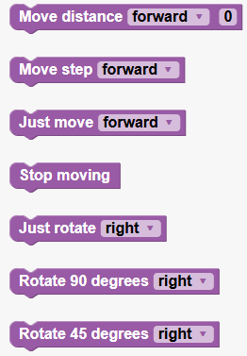
Figure 1 Available movement options for FOSSBot
Activity 2: Understanding how the ultrasonic sensor works in combination with the FOSSBot’s movement. The student(s) should create a simple program that tells the FOSSBot to move forward until an obstacle is detected, then rotate 90 degrees on the left and then move forward again. The distance parameter should be adjusted based on the available space.
Activity 3: Programming the FOSSBot to move through traffic utilising the movement commands, the ultrasonic sensor, and the built-in LED. Student(s) should create a maze on the floor with several obstacles. Then student(s) should create a program that lets the FOSSBot navigate the maze until it reaches the exit. The maze can be created using various objects in the classroom, such as chairs, desks, cardboard boxes, and any other object seemed appropriate. For the sake of this activity, we present a simple maze where the FOSSBot has to do two rotations until reaching the exit.
An assessment quiz is available at the end of the activities that covers the described concepts (multiple choice and true/false questions).
Important: To implement the activities, the FOSSBot must be pre-synchronized with the local Wi-Fi network and the students should be familiar with the programming interface.

2.2 Worksheets
Activity 1
Movement commands:
- Move distance forward/reverse X: FOSSBot moves forward or in reverse X centimetres.
- Move step forward/reverse: FOSSBot moves forward or in reverse just a step (1 centimetre).
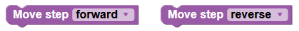
- Just move forward/reverse: FOSSBot moves forward or in reverse forever.
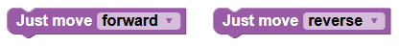
- Stop moving: FOSSBot stops any movement.

- Just rotate right/left: FOSSBot rotates either right or left forever.

- Rotate 90 degrees right/left: FOSSBot just rotates 90º to either right or left.
- Rotate 45 degrees right/left: FOSSBot just rotates 45º to either right or left.
Now that students are familiar with FOSSBot’s movement commands, they can create a simple program that does the following:
      - FOSSBot moves forward at a distance of 5cm
      - FOSSBot rotates 90 degrees to the left
      - FOSSBot moves a step in reverse
      - FOSSBot rotates 45 degrees to the right
      - FOSSBot moves in reverse at a distance of 10 cm

Activity 2
Using the ultrasonic sensor on the FOSSBot the following command should be used:

The ultrasonic sensor will “sense” an obstacle at a given distance and will notify the FOSSBot to do an action. Seeing how the ultrasonic sensor works, students should create the following program and test by placing an object and various distances.
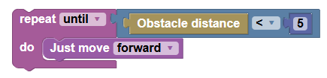
The program tells the FOSSBot to move forward until the ultrasonic sensor detects an object at a distance of less than 5cm.
Activity 3
Now that students are familiar with the FOSSBot movement and ultrasonic sensor, it is time for a more challenging activity. Student(s) should create a maze on the floor with several obstacles. Then student(s) should create a program that lets the FOSSBot navigate the maze until it reaches the exit. The maze can be created using various objects in the classroom, such as chairs, desks, cardboard boxes, and any other object seemed appropriate.
We have created a simple maze to inspire students with theirs. In our example, FOSSBot moves forward, then rotates right, then moves forward, then rotates left, then finds the exit. We also utilise the build-in LEDs, the print function, the repeat loop, and the sleep function.
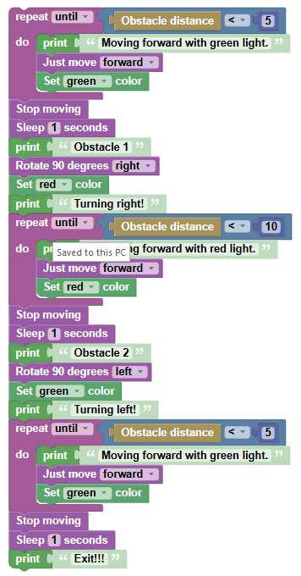

Knowledge Assessment Activities
- Which command tells the FOSSBot to use the ultrasonic sensor?
a) Print
b) Set
c) Obstacle distance
d) Floor sensor
- In which block palette can someone find the command “repeat while/until”?
a) Logic
b) Loops
c) Interaction
d) Sensors
- Which function tells the FOSSBot to wait?
a) Set
b) Print
c) Sleep
d) Draw
- Which sensor can detect the presence of an object?
a) Light Sensor (Photoresistor)
b) Noise Sensor
c) Gas Sensor
d) Ultrasonic Sensor
- To create a loop that continues to run until a condition is satisfied, we use:
a) if - do
b) repeat while
c) for each item
d) repeat until

Correct Answers:
1.c, 2.b, 3.b, 4.d, 5.d,

