TITLE OF THE EDUCATIONAL SCENARIO
Energy-Efficient Robot Operations with FOSSBot
SUBJECT
Environmental sustainability, robotics & physics

1. IDENTIFICATION OF THE SCENARIO
1.1 Scenario title
Energy-Efficient Robot Operations with FOSSBot
1.2 Target age group
Secondary school years 10 to 13 (15-18 years old)
Curriculum: Secondary school
Subject area: Robotics, Computer Science, Technology, Environmental Education
Topics/subtopics: Block programming, Sensors, Robotics
Setting and resources: Classroom or lab with FOSSBot robots (or FOSSBot simulators on computers), Blockly programming interface, measuring tape/ruler (for distance), stopwatches, and worksheets. Students work in small teams for hands-on tasks.
Expected learning outcomes:
Students will:
• Understand the concept of energy efficiency and why reducing energy consumption is important for environmental sustainability.
• Program FOSSBot using a visual, block-based programming environment, applying loops and conditional structures.
• Use onboard FOSSBot sensors (such as the ultrasonic sensor) and motor settings to observe how robot behavior influences energy consumption.
• Measure and interpret distance, time, and speed to analyse the relationship between motion and energy use.
• Collaborate in small teams to design, test, and optimise robot programs for more energy-efficient operation.
• Connect STEM learning to real-world energy challenges, understanding how efficient use of technology contributes to sustainable development and reduced environmental impact.
1.3 Estimated duration
90 minutes

1.4 Subjects covered
Technology, Computer Science, Engineering Sciences, environmental education
1.5 Prerequisite knowledge
Students must be familiar with a visual programming environment. They must be able to create and debug programs. They must understand the concepts of loops and conditional statements and have applied them in a visual programming environment.

1.6 Objective of the scenario
At the end of the scenario, students are expected to have developed an understanding of how energy is consumed by a robotic system and how programming choices can improve energy efficiency. They will explore the relationship between robot motion, motor power, sensor use, and energy consumption, and relate these concepts to real-world environmental challenges.

1.6.1 Learning objectives/outcomes
Students will:
- Understand the concept of energy efficiency and why reducing energy consumption is important for environmental sustainability.
- Program FOSSBot visually (block-based) using loops and conditional instructions.
- Use onboard FOSSBot components and sensors (ultrasonic sensor, motors) within realistic robot capabilities to analyse energy-related behaviour.
- Measure and interpret distance, time, and speed to evaluate how robot motion affects energy use.
- Collaborate and iterate to optimise robot behaviour for more energy-efficient operation.
- Connect STEM learning to sustainability, as encouraged in European education frameworks that promote responsible energy use and real-world problem solving.

1.6.2 Educational objectives
Through teaching, the educator aims to:
- Develop students’ technical skills in educational robotics and basic programming.
- Strengthen algorithmic thinking through the use of conditions, loops, variables, and sensor feedback.
- Encourage creativity and autonomy through hands-on experimentation and code modification.
- Promote collaboration, communication, and shared problem solving within groups.
- Raise students awareness of how simple technological choices can contribute to energy saving and environmental protection.

Examples of technological applications related to energy efficiency:
- Energy-efficient motor control in robots and automated systems.
- Smart systems that reduce energy waste by stopping devices when not in use.
- Autonomous robots that optimise routes to minimise distance traveled and energy consumption.
- Intelligent transportation and automation systems designed to lower energy use and reduce emissions.

2. DEVELOPMENT OF THE LESSON PLAN
2.1 Description of teaching and learning activities
This scenario is based on experiential and inquiry-based learning, using the FOSSBot2.0 educational robot and its visual, block-based programming environment, in accordance with the STEPS project pedagogical approach.
The learning process focuses on exploration and experimentation. Students are encouraged to test sensor behaviors, adjust parameters, and refine their programs through observation and trial and error. No fully completed solution is provided, allowing learners to actively construct their understanding.
Collaborative learning is reinforced through teamwork, with students working in groups of 3 to 5 learners to design, program, and test their robotic solutions. This approach strengthens social interaction, communication skills, and collective knowledge building.
The scenario integrates gamification elements to increase motivation and engagement. Students take on the role of a “waste management patrol” and create interactive robotic behaviors using sensors, LEDs, sound signals, and movement, resembling game-like challenges.
A worksheet is used to guide students through five (5) consecutive activities:
2.1 Description of teaching and learning activities
Activity 1: Exploring FOSSBot Hardware & Power Usage – Introduction (15 min). The teacher introduces the FOSSBot robot to the class, either by showing a physical unit or projecting images. Students observe the robot’s hardware components and identify which parts might consume electrical energy. Key components highlighted include the two drive motors (one for each wheel), the battery pack, the ultrasonic sensor “eyes” (for distance sensing), lights/LEDs, and other sensors (like line-following sensors and a speaker). In small groups, students examine the robot (or detailed pictures) and discuss: “Which parts do you think use the most power from the battery?” The teacher guides them to realize that moving parts (motors) require much more energy than passive sensors or the tiny LED. For example, spinning the wheels (motor activity) drains the battery much faster than the ultrasonic distance sensor simply detecting distance. Students list all parts of FOSSBot that need energy (motors, sensors, microcontroller, speaker, LED, etc.) and rank them by expected power use. The teacher can confirm that motors are indeed the largest energy consumers on the robot – analogous to how an engine uses most of a car’s fuel. (If available, the teacher may demonstrate the battery sensor on FOSSBot’s interface to show battery level dropping faster when motors run. This activity builds a foundation, as students get familiar with the robot and connect its components to energy consumption in principle.
Activity 2: Measuring Energy Consumption at Different Motor Speeds – Investigation (25 min). Students now explore how motor power (speed setting) affects the robot’s performance and energy usage. Using the FOSSBot Blockly programming interface, each group writes a simple program to drive the robot forward for a fixed amount of time (for example, 5 seconds) at a chosen motor power level. They perform this test at multiple power settings (e.g. 50% speed vs 100% speed) and measure the distance the robot travels in that time. (In simulation or with a physical robot, they can mark the start point and end point and use a ruler or measuring tape for distance.) Students record their results in a table, noting for instance: at 50% power the robot traveled X cm in 5 seconds; at 100% power it traveled about 2× X cm in 5 seconds, etc. They calculate the approximate speed (cm per second) for each power level. Next, the class discusses energy implications: higher power draws more current from the battery. The teacher prompts, “Did the robot use more battery to go faster? Or was it more ‘efficient’ in terms of distance per battery unit?” Students consider that while the fast robot covered more distance in the same time, it likely drained more battery per second. If available, the teacher might demonstrate a qualitative sign of energy use – for instance, feeling the motors or battery get slightly warm at full power (indicating energy loss as heat), whereas at half power they remain cooler. Students learn that moving very fast can waste energy (due to factors like increased friction or inefficiencies), similar to how driving a car at top speed wastes fuel. On the other hand, moving too slowly for too long isn’t efficient either (since the robot is active for longer). They infer there is an optimal range for efficiency. This experiment helps students link the abstract concept of energy consumption to tangible data: more power = higher speed but also higher energy draw. They also practice using sensor data or measurements – for example, if using an odometer sensor, they could directly get distance readings. By the end, students should be able to explain that running motors at full throttle rapidly uses energy, and moderate speeds might be more sustainable for the battery. (The teacher can relate this to real-world vehicles: cars use more fuel at very high speeds due to wind resistance and engine strain, which is why efficient driving saves fuel.)
Activity 3: Programming Energy-Efficient Robot Behavior – Application & Problem-Solving (30 min). In this deeper activity, students apply what they’ve learned to optimize the robot’s behavior for energy efficiency. The teacher sets up a scenario: “Our FOSSBot must travel to a destination while using as little energy as possible. How can we program it to be energy-efficient?” Students identify two major strategies: avoiding wasteful idling and choosing efficient paths. First, they tackle idling. The teacher explains that when machines (or cars) idle (run in place without moving), they waste energy. In robotics, this could mean motors humming or wheels slipping when the robot is stuck or waiting. Using Blockly, students modify their code so that the robot’s motors shut off when the robot is not moving or when waiting. For example, if the robot needs to pause (simulating a stop light or waiting for an obstacle to clear), they insert a command to set motor power to 0 during the wait. They can simulate a comparison: one run where the robot “waits” for 5 seconds with motors still on (e.g. power at 20, so it’s idling slowly), and another run where the robot waits 5 seconds with motors off. After each, they observe battery impact or listen to motor sound – clearly, turning motors off saves energy (and reduces heat/noise). The teacher connects this to real vehicles: turning off an engine at a red light saves fuel (billions of gallons are wasted by idling vehicles every, so this is a big deal in sustainability). Next, students focus on path efficiency. The teacher arranges a simple obstacle course or provides a virtual map in the simulator: e.g. the robot must start at Point A and reach Point B, with an obstacle (like a box or cone) in between. Each team brainstorms how to get to B using the least distance or time. Some may choose to go straight toward B, then stop and wait if the obstacle blocks the way until it’s “removed” (teacher simulates removal), then continue – this yields a shorter path but includes a stop. Others might choose to take a longer detour around the obstacle without stopping. Students program their chosen route in Blockly, using sensor feedback if appropriate (for example, use the ultrasonic sensor to detect the obstacle: “if distance < 10cm, then stop and wait, else keep going”). They test their solutions and measure total distance traveled or total time taken. Then groups compare results: which approach used less energy? Generally, the shortest route that avoids unnecessary movement will use less energy, especially if the robot wasn’t idling during the wait. Students discover that avoiding extra distance is important – optimizing the trajectory between start and end can save a significant amount of energy (studies show efficient path planning can cut robot energy use by 15–30%arxiv.org). They also see that if a stop is required, it’s best to cut the motors during that time. Through this, the class distills some “best practices” for energy-efficient robotics: (1) Cut the power when stopped – don’t waste energy by idling, and (2) Take the smart shortest path – avoid wandering or detours when not necessary. The teacher steers discussion to how autonomous cars or delivery robots might do the same: using sensors to avoid traffic and plan short routes, and shutting off motors when appropriate (many modern cars have “start-stop” systems to turn off at idle). This activity solidifies students’ ability to write programs that integrate sensor input (ultrasonic distance, etc.) with conditional logic to achieve a goal in a more sustainable way. It highlights the role of automation and coding in solving real-world problems like energy conservation.
Activity 4: Reflection and Assessment – Energy Efficiency Quiz – Conclusion (20 min). To conclude, students reflect on what they learned about energy efficiency and robotics. The teacher administers a short comprehension check in the form of a quiz or interactive worksheet. This can include a mix of question types (multiple-choice, short answer, or a drag-and-drop text activity if digital). For example, a few quiz questions might ask: “Which FOSSBot component uses the most energy? (A. Ultrasonic sensor, B. Wheel motors, C. LED)” – students would answer motors (reinforcing Activity 1). Another question: “True or False: A robot’s battery lasts longer if the robot stops its motors when not moving” – answer True (from Activity 3). There might also be a question requiring calculation or observation from Activity 2’s experiment (e.g., “At 50% speed FOSSBot went 40 cm in 5s; at 100% speed it went 80 cm in 5s. Which used more battery power, or was it the same? Explain briefly.” Students might respond that 100% speed used more power even though it was faster). Finally, the teacher leads a short discussion: “How does what we did with FOSSBot relate to saving energy in the real world?” Students are encouraged to cite examples (turning off lights and devices when not used, avoiding car idling, taking shorter routes to school, etc.). This reflection solidifies the connection between the hands-on robotics activities and broader environmental sustainability goals – students realize that small changes in behavior or design (whether in code or in everyday life) can lead to meaningful energy savings. They come away with the understanding that technology and programming can be leveraged to reduce energy waste, making both robots and real-world systems more sustainable.

To carry out the activities, the FOSSBot2.0 must be pre-synchronized with the local Wi-Fi network, and students must access the FossBot programming interface from a computer or tablet connected to the same network.
2.2 Worksheets
Activity 1
FOSSBot Hardware and Energy Usage

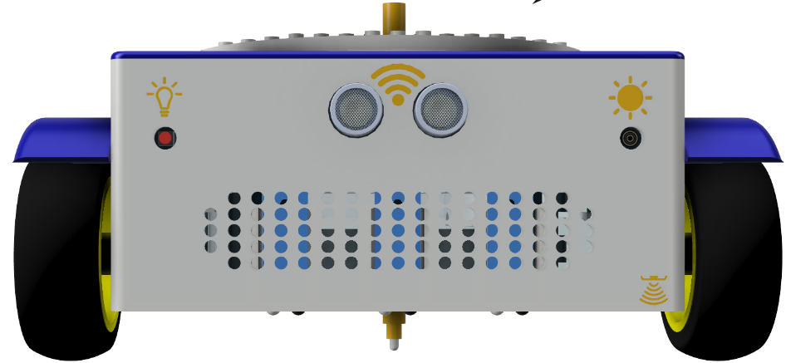
Label the components: In the figure above, identify the following parts of FOSSBot:
a. Motors/Wheels – these make the robot move (hint: the wheels on the sides, powered by motors inside).
b. Ultrasonic sensors – look like “eyes” on the front; they detect distance to obstacles.
c. Light sensors – indicated by the sun symbols, they detect ambient light.
d. Battery – inside the robot (not visible here), it provides power to all components.
e. LED indicator – an RGB light on the robot (visible on the front/top) that uses some power.
Energy use discussion: Which parts of FOSSBot do you think use the most energy from the battery? Circle your choices: (motors, sensors, LED, speaker, microcontroller). Explain your reasoning: _______________________________________________________.

Battery life thinking: Why is it important for engineers to know which robot components use the most energy? Write one idea: ________________________________________________________________.
(Example answer might be: “So they can improve those parts or use them wisely to make the battery last longer.”)
Activity 2
Familiarisation with the FOSSBot programming environment
Using an image creation tool (such as https://h5p.org/image-hotspots), interactive points will be created on the buttons in the image below to describe the function of each one:
- Save the code
- FOSSBot interface home page
- Run the programme
- Stop programme execution
- Recycle bin
- Block palette
- Tile drop zone
Activity 2 – Practical discovery
- Open the FOSSBot. Wait a few seconds for it to connect to your local network.
- On a computer or laptop connected to the same network as the robot, open Chrome or Firefox and go to the URL: http://fossbot-000.local:8081 to access the FOSSBot interface.
- Upload the project “obstacle black box.xml”.
- Click Edit.
- Run the project.
- What do you observe?
………………………………………………………………………………………………………………………..
………………………………………………………………………………………………………………………..
- Go to the homepage of the FOSSBot interface.
- Select settings
- Change the value to “obstacle detected True if sensor value smaller than” so that FOSSBot stops relatively close to any obstacle. Save the changes.
- Return to editing mode on the task “obstacle black box.xml”.
- Run  the project.
- What do you observe?
……………..………………………………………………………………………………………………………..
………………………………………………………………………………………………………………………
- If FOSSBot does not stop in the correct position you expected, repeat steps 7-12

Activity 3
Experimenting with Motor Power
- Program your robot to move straight up to 15 cm from the scene obstacle.
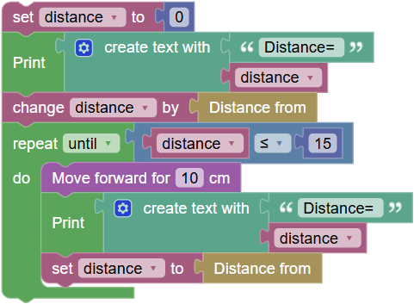
- Record, observing Copellia, how long it took her to travel this distance.
……………………………………………………………………………………………………………………………..
- Create a variable “time ” to record the time from fossbot-app and initialize it (value=0) .
- Where in the code should you place this tile?
…………………………………………………………………………………………………………………….……..
- Enable the timer at the beginning of the code
- At the end of the code (excluding repetition) the elapsed time should be displayed on the fossbot-app screen.
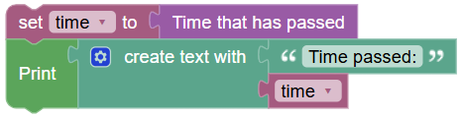
- Disable the timer at the end of the code
- Save your project and go to the app home page 
- Go to FOSSBot settings and change the left and right motor speed values “Left motor speed 0-100%” and “Right motor speed 0-100%” to 100%. Save the changes of the parameter
- Go back to the velocity project and run it again.
In this activity, you tested FOSSBot at different motor power levels and measured distances. Use your data and observations to answer the questions below:
- Complete the data table: (If you did not already, fill in the results from your experiment.)
Motor Power Setting (% speed) | Distance Traveled in 5 seconds (cm) | Approximate Speed (cm/s)
50% power | ________ | ________
100% power | ________ | ________
- Based on the class average, at 50% power the robot traveled about ______ cm, and at 100% power it traveled about ______ cm in the same time. (Fill in typical values observed, e.g. 50%: 40 cm, 100%: 80 cm.)
- Speed vs. energy: Which run do you think used more battery energy – the 50% power or 100% power run, or were they about the same? Explain your answer.
  - Answer: _______________________________________________________________
(Hint: The 100% run drew more current – the motors worked harder – so even though it was quicker, it likely consumed energy faster. The 50% run used less power each second but ran longer to cover the same distance. Many factors can affect this, but generally higher power means higher energy use.)
- Efficiency consideration: If FOSSBot needed to travel a fixed distance (say 1 meter), would you recommend it go very fast or moderately fast to use energy efficiently? _______________. Why?
  - Explanation: __________________________________________________________
Discuss with your group. (Think about things like friction or the motors straining – extremely high speed might waste energy as heat and require more power input. There is an optimal speed that isn’t too slow or too fast.)
- Real-world connection: Cars on a highway often get better fuel efficiency at moderate speeds than at maximum speed. How does this relate to your robot experiment?
  - Answer: _______________________________________________________________
(Answer could mention that both cars and robots use more energy when going very fast because the engine/motors have to work harder against forces like drag or friction, so there’s a “sweet spot” speed that uses energy more sparingly.)

Activity 4
Now you programmed FOSSBot to behave in more energy-efficient ways. Answer these questions about the activity:
- Efficient route planning: Draw a simple map below (or on the board) of the path your robot took to reach the destination around an obstacle. Then, sketch an alternative path that might be longer. Mark which path is shorter.
(Students draw two paths: one short with maybe a stop, one longer detour. They label distances.)
  - Which path would use less energy for the robot? ________________ (shorter or longer path?)
  - Why? _________________________________________________________
Answer guidance: The shorter path generally means the robot drives a shorter distance, using less battery overall. Even if it had to pause, if the motors were off while pausing, it didn’t use much energy during the wait. A longer path means the motors had to run for a greater distance/time, consuming more energy from the battery.
- Sensor use: What sensor did you use to detect the obstacle, and how did that help save energy?
  - Sensor: ____________________ (e.g. ultrasonic sensor).
  - It helped save energy by ____________________________________________________.
(Example: “the ultrasonic sensor detected the obstacle from 10 cm away, so the robot could stop early instead of hitting it and pushing against it. Stopping early means no energy wasted trying to push a blockage.” Or “the sensor allowed the robot to decide to take a shorter route when it ‘saw’ the path was clear, avoiding a long detour.”)
Activity 5
Knowledge assessment activities
Which FOSSBot component consumes the most energy during operation?
a) Ultrasonic sensor
b) LED indicator
c) Motors
d) Microcontroller
Which programming structure allows the robot to change its behaviour based on a condition (for example, stopping when an obstacle is detected)?
a) Variable
b) Event
c) Loop
d) If… then… else
When the speed (power) of the FOSSBot motors is increased, the robot’s energy consumption generally:
a) Decreases
b) Remains the same
c) Increases
Which action helps improve the energy efficiency of the robot?
a) Letting the motors run while the robot is stopped
b) Increasing the speed as much as possible
c) Turning off the motors when the robot is not moving
d) Making the robot take a longer path
Which strategy is most appropriate to reduce energy consumption during robot movement?
a) Choosing the longest route to the destination
b) Moving at maximum speed at all times
c) Optimising the path and avoiding unnecessary movement
d) Ignoring sensor information

