TITLE OF THE EDUCATIONAL SCENARIO
Discovering and using ultrasonic sensors: understanding automation and the use of sensors in a robotic system

SUBJECT
Technology

1. IDENTIFICATION OF THE SCENARIO
1.1 Scenario title
Discovering and using ultrasonic sensors on an educational robot: understanding automation, obstacle detection and bat-inspired guidance
1.2 Target age group
Grade 10 to 13 (15-18 years old)
Curriculum: Senior high school
Subject area: Robotics, Computer Science, Technology
Topics/subtopics: Block programming, Sensors, Robotics
Expected learning outcomes:
Students will be able to:
- Explain the principle of an ultrasonic sensor and its applications.
- Use a simplified programming interface (blocks) to control the robot.
- Program simple robot responses based on the values returned by the sensor.
- Interpret and use sensor data to adjust the robot's movements.
1.3 Estimated duration
120 minutes

1.4 Subjects covered
Technology, Computer Science, Engineering Sciences
1.5 Prerequisite knowledge
Students must be familiar with a visual programming environment. They must be able to create and debug programmes. They must understand the concepts of loops and conditional statements and have applied them in a visual programming environment.

1.6 Objective of the scenario
By the end of the lesson, students should have:
- Understood how an ultrasonic sensor works.
- Programmed the educational robot to detect obstacles and react accordingly.
- Drawn an analogy with the echolocation system used by bats.
- Developed their ability to solve technical problems collaboratively.

1.6.1 Learning objectives/outcomes
Students will be able to:
- Explain the principle of an ultrasonic sensor and its applications.
- Compare the principle of an ultrasonic sensor to the echolocation system used by bats.
- Use a simplified programming interface (blocks) to control the robot.
- Program simple reactions of the robot based on the values returned by the sensor.
- Interpret and use the sensor data to adjust the robot's movements.
1.6.2 Educational objectives
Through teaching, the educator aims to:
- Develop students' technical skills and algorithmic logic.
- Encourage creativity and autonomy through experimentation.
- Promote collaboration and the exchange of ideas within the group.
- Raise students' awareness of the practical applications of ultrasonic sensors in everyday life and industry.
Examples of uses for ultrasonic sensors:
- Parking assistance systems for cars.
- Robotic vacuum cleaners capable of avoiding obstacles.
- Automatic measurement of liquid levels in industrial tanks.
- Detection of people or objects to automatically activate automatic doors.

2. DEVELOPMENT OF THE LESSON PLAN
2.1 Description of teaching and learning activities
This scenario uses experience-based and research-based learning, using the FOSSBot2.0 robot and its visual programming environment.
The learning process focuses on exploration, encouraging students to experiment with commands and conditions by creating an interactive project. No ready-made solutions are provided, which promotes the discovery of knowledge through observation and trial and error.
Collaborative learning is reinforced through teamwork, with students working in groups of 3 to 5 to develop their projects, strengthening social interaction and collective knowledge building.
The scenario incorporates elements of gamification, which add motivation and engagement to the learning experience. Students create interactive projects using sensors, light-emitting diodes, and the computer screen, evoking gaming experiences.
A worksheet is used for teaching, guiding students through five (5) consecutive activities:
Activity 1: Introduction to how the ultrasonic sensor works. Brief theoretical presentation (measurement principle, emission and reception of sound waves), accompanied by an explanatory analogy with bat echolocation.
Activity 2: Discovering the block programming interface. Students explore and identify the blocks needed to manage the ultrasonic sensor (reading, logical conditions).
Activity 3: Basic programming of the robot to detect obstacles. Students create a simple programme that allows the robot to stop when it detects an obstacle at a certain distance.
Activity 4: Advanced programming. Students improve their programme to enable the robot to automatically avoid obstacles (bypassing, changing direction).
Activity 5: Assessment of acquired knowledge. Interactive quiz to consolidate learning.

To carry out the activities, the FOSSBot2.0 must be pre-synchronised with the local Wi-Fi network.

2.2 Worksheets
Activity 1

Introduction to how ultrasonic sensors work
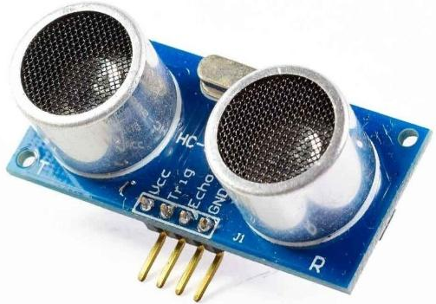
Ultrasonic sensors are electronic devices capable of measuring distances using high-frequency sound waves (inaudible to humans). Their basic principle is echo: the sensor emits an ultrasonic sound and listens for its echo after it has been reflected off an obstacle, similar to the sonar used by bats to navigate.
Operating principle and main components
How an ultrasonic sensor works: the transmitter sends an ultrasonic sound wave (arrow) towards an obstacle, then the receiver picks up the echo wave sent back to the sensor. An ultrasonic sensor measures distance by emitting a brief ultrasonic pulse and then measuring the time it takes for the wave to return after bouncing off an object. Knowing this delay, the system calculates the distance𝑑 to the object using the formula$v=2*\frac{d}{∆t} ⇒d=\frac{v*∆t}{2}$ , where𝑣 is the speed of sound in air.
Question: In your opinion, why is the distance multiplied by 2?
Answer: ……………………………………………………………………………………………………………..

Each sensor has two main components: a transmitter (often a piezoelectric transducer that generates the ultrasonic wave) and a receiver (which picks up the returned echo). In practice, these two elements are placed side by side on the module. An electronic circuit (e.g. a microcontroller) sends the ultrasonic pulse and times the return of the echo in order to calculate the corresponding distance.
Examples of uses for ultrasonic sensors
Ultrasonic sensors have many practical uses:
- Automotive: parking systems (reversing sensors) and collision avoidance systems use ultrasonic sensors to continuously measure the distance to obstacles around a vehicle
- Robotics: mobile robots and drones are equipped with these sensors to detect obstacles and navigate without colliding, by assessing the distance to nearby walls or objects
- Industry: in industrial environments (warehouses, factories), they are used to detect objects on a production line or measure the fill level of tanks, even in the presence of dust, smoke or other airborne particles. Unlike infrared sensors, ultrasonic sensors remain effective in dusty or smoky air.
- Medical: Ultrasound and other medical scanners use ultrasonic waves – based on the same principle of reflected waves – to visualise the inside of the body (foetal imaging, tumour detection, etc.) in a non-invasive way.

Mathematical explanation of distance calculation
The distance detected by the sensor is calculated from the travel time of the ultrasonic wave and the speed of sound. In air, the speed of sound is approximately 340 m/s at room temperature. Thus, if Δ𝑡 is the time measured between the emission and return of the echo, the distance can be estimated using the formula: $v=2*\frac{d}{∆t} ⇒d=\frac{v*∆t}{2}$
For example, if𝑣 =340 m/s and Δ𝑡 =0.001 s (1 millisecond), we obtain$d≈\frac{340*0.001}{2}=0.17 m$ , or 17 cm.
Influence of temperature: In reality, the speed of sound depends on the temperature of the air. It is approximately 331 m/s at 0 °C and increases by approximately 0.6 m/s per degree Celsius – for example, ~343 m/s at 20 °C. We can use the approximate relationship𝑣 ≈331+0.6 *𝜃 (where𝜃 is the temperature in °C) to estimate𝑣 at a given temperature.
Echolocation in bats
Some animal species naturally use biological sonar similar to ultrasonic sensors. This is the case for bats, which "see" in the dark by emitting ultrasonic waves and listening to their echoes to orient themselves in space and locate obstacles or prey. In practical terms, bats produce ultrasonic waves using their larynx and emit them through their mouth (or nose); when these waves encounter an obstacle (e.g. an insect), they bounce back and return to the bat in the form of an echo, which is picked up by its ears. By analysing the delay and characteristics of this echo, its brain can assess the distance, size or shape of the object encountered. We can draw an analogy with technological sensors: the emitting source is the bat itself (emitting organ: larynx/mouth), the receiver is the animal's ear, and the computer that processes the information is its brain.
Application exercise
A mobile robot is equipped with an ultrasonic sensor to measure distances in front of it. Suppose that this sensor sends a pulse and receives the echo Δt = 880 μs (microseconds) later. Calculate the distance𝑑 between the robot and the detected obstacle. (We will take v=340 m/s for the speed of sound in air, and express𝑑 in centimetres.

Distance = …………………………………………………………………………………………………………………..
Activity 2
Familiarisation with the FOSSBot programming environment
Using an image creation tool (such as https://h5p.org/image-hotspots), interactive points will be created on the buttons in the image below to describe the function of each one:
- Save the code
- FOSSBot interface home page
- Run the programme
- Stop programme execution
- Recycle bin
- Block palette
- Tile drop zone
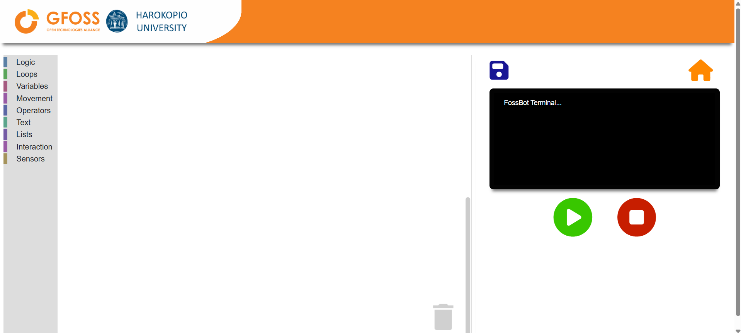

Activity 2
- Open FOSSBot. Wait a few seconds for it to connect to your local network.
- On a computer or laptop connected to the same network as the robot, open Chrome or Firefox and go to the URL: http://fossbot-000.local:8081 to access the FOSSBot interface.
- Download the "black box lights.xml" project from .
- Click Edit.
- Run the project.
- What do you observe?
...................................................................................................................................
...................................................................................................................................
- Make the necessary changes so that the light switches more quickly. What did you change?
...................................................................................................................................

Activity 3
Basic robot programming to detect obstacles.

- Go to the FOSSBot interface home page at .
- Create a new project.
- Name it "Obstacle Detection".
- In the "brief description of the new project", you can write: "Create a forward movement to park the robot while avoiding a collision".
- First, we will need a sensor to detect obstacles and the robot's distance from them. To do this, we will use an HC-SR04 ultrasonic sensor.
- Find the range of values for your sensor that indicates distance, using the blocks shown below and running the programme:
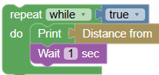

- Find the sensor's limits by moving your object. :
Minimum distance: .......................................
Maximum distance: .......................................
- Draw the detection areas on a sheet of paper to measure the sensor's detection cone.
Detection cone = …….. Deg
- Stop programme execution.
- Modify your programme using the blocks below to move the robot towards a wall and stop it when it detects an obstacle 5 cm away. Display the message "Obstacle detected at xxx cm".
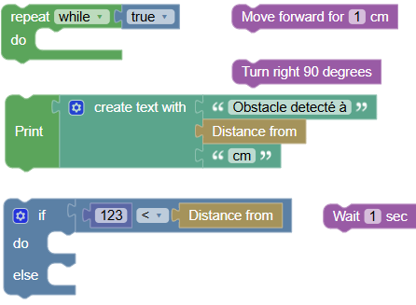
- Run your programme. The values are displayed on the screen.
- Modify your programme so that the robot flashes an LED and alerts the user with an audible signal when the distance between the robot and the wall is less than 10 cm.
Activity 4
Basic robot programming to detect obstacles.
- Go to the FOSSBot interface home page at .
- Create a new project.
- Name it "Obstacle Avoidance".
- In the "brief description of the new project", you can write: "Create a straight line movement while avoiding an obstacle".
- Modify your programme using the blocks below to make the robot move forward and turn 90° to the right when it detects an obstacle 15 cm away. Display the messages "Obstacle detected at xxx cm".
- Run your programme. The values are displayed on the screen.
- Modify your programme so that the robot goes around an obstacle
Activity 5
Knowledge assessment activities

- Which of the following buttons creates a new project in the FOSSBot interface?
a)
b)
c)
d)
- In which palette block can the "if... then ... else" command be found?
a) Logic
b) Loops
c) Interaction
d) Sensors
- Which sensor detects the distances to objects in front of the robot?
a) Ultrasonic sensor
b) Light sensor (photoresistor)
c) Noise sensor
d) Gas sensor

- To evaluate two conditions at the same time, we use the logical operator...
a) or
b) and
c) not
- The closer an object is, the higher the value of the ultrasonic sensor.
a) True
b) False

