SCENARIO TITLE
Solar Oven
SUBJECT
Computer Science, Environmental Science, Technology and Design

1. SCENARIO IDENTIFICATION
1.1 Scenario Title
Solar Oven
1.2 Target Age Group
Grades 7–8 (Secondary School)
Curriculum: Upper Secondary School
Thematic Area: Renewable Energy; Engineering Design; Heat Transfer, Greenhouse Effect
Topics/Subtopics: Solar energy conversion to heat, Surface properties: dark vs light, matte vs reflective, Trapping heat (greenhouse cover) and reducing losses (insulation)

Expected Learning Outcomes:
By the end of the lesson, Students will be able to:
- Explain how reflection, absorption, insulation, and a transparent cover contribute to heating.
- Define a measurable design criterion (e.g., reach 60 °C or soften chocolate in 10 min) and constraints (materials, time, safety).
- Build a working solar oven with available materials.
- Collect, record, and graph temperature vs. time; compare trials.
- Propose evidence-based improvements to increase performance.

1.3 Estimated Duration
45 minutes
1.4 Subject Areas Involved
Science (Energy/Heat), Mathematics (data & graphs), Technology/Design
1.5 Prerequisite Knowledge
Basic heat concepts (temperature, insulation), reading a thermometer
1.6 Purpose of the Scenario
To give students a concrete, hands-on experience of how a simple device can capture, direct, and retain solar energy while they practice the engineering design cycle—plan → build → test → improve—and connect heat-transfer concepts (absorption, reflection, insulation, greenhouse trapping) to real-world problem solving.
1.6.1 Learning Objectives/Outcomes
By the end of the scenario, students will be able to:
- Identify how reflectors (collect), black surfaces (absorb), clear cover (trap), and insulation (retain) affect heating.
- Define a measurable criterion and work within constraints (materials, time, safety).
- Build and operate a working solar oven.
- Collect, record, and interpret temperature–time data (including locating start/rise/peak/plateau).
- Propose evidence-based improvements and everyday applications.
1.6.2 Teaching Objectives
Through teaching, the educator aims to:
- Enhance technological and sustainable thinking.
- Foster problem-solving and creative thinking in STEM context.
- Promote responsible citizenship.
- Encourage collaboration and communication.
- Integrate science and technology.

2. LESSON PLAN DEVELOPMENT
2.1 Description of Teaching and Learning Activities
The teaching and learning activities are designed as a structured sequence that combines hands-on experimentation with interactive digital tasks supported by FOSSBot. The lesson begins with an icebreaker in which FOSSBot illustrates the flow of energy through a short journey, followed by an H5P grouping activity that helps students categorize key concepts such as energy sources, conversions, and uses. In the next stage, students collaboratively build solar ovens with simple materials, guided step by step by FOSSBot’s digital instructions. Once the ovens are ready, learners record temperature data during the cooking process, entering values into FOSSBot and later reinforcing their understanding through an H5P drag-and-drop activity that matches temperature readings with real-life observations. To deepen inquiry, groups compare ovens made with different materials and analyze which design is more effective, with FOSSBot providing immediate feedback. The lesson concludes with a reflection and Idle-Off simulation, where students experience the importance of energy-saving behaviors and connect the solar oven experiment to sustainable daily practices. This flow balances inquiry-based science learning, technology integration, and environmental awareness while fostering collaboration and critical thinking.
Flow and content of activities:
Activity 1 : Energy Journey Icebreaker (Grouping)
At the beginning of the lesson, students explore how energy flows in a playful way. FOSSBot follows a short line path and stops at three stations, displaying messages such as “Energy Source,” “Energy Conversion,” and “Energy Use.” This short journey illustrates the stages of energy transformation. Then, students complete an H5P Grouping activity where they drag concept cards such as Sunlight, Foil, Trapped Heat, and Cooked Food into the correct categories: Source, Conversion, and Use. In this way, both the robot’s demonstration and the digital interaction serve as an icebreaker to introduce the topic.
Activity 2: Building the Solar Oven
In the second stage, students work in groups to build their own solar ovens. Using cardboard boxes, aluminum foil, black paper, and plastic wrap, they construct their ovens step by step. FOSSBot acts as a digital guide, displaying instructions on its screen such as “Cover with foil,” “Place black paper,” and “Seal with plastic film.” This allows students to follow the building process both physically and digitally.
Activity 3: Measuring and Recording
Once the solar ovens are complete, students place food (e.g., chocolate or marshmallows) inside and start the experiment. They measure the temperature every 10 minutes with a thermometer and manually enter the values into FOSSBot. The robot displays the trend on its screen. At the end of this stage, students complete an H5P Drag & Drop activity where they match temperature readings with observations, for example, 25 °C → “No cooking yet,” 33 °C → “Chocolate softens,” 44 °C → “Marshmallow melts.” This digital exercise strengthens data interpretation skills and links experimental results to observations.
Activity 4: Material Comparison
In the fourth stage, groups test solar ovens built with different materials. One group uses foil, while another uses plain cardboard. Each group enters their maximum recorded temperature into FOSSBot. The robot displays the values side by side and provides feedback such as “Foil is more efficient” or “Plain oven is higher – check construction.” In this way, students observe directly which materials better reflect sunlight and trap.

Activity 5: Reflection
In the final stage, students reflect on the results and connect them to daily life. FOSSBot stops at three markers and initiates a 3-second countdown game. If a student presses the button in time, the robot records +0 points; if not, it records “Idling (+2).” This simulates the importance of energy saving. Students then complete small matching and drag & drop tasks, linking actions such as “Turn off lights” → “Save electricity” and classifying habits like “Driving Alone” (High Impact) and “Using Solar Oven” (Low Impact). This final activity reinforces the connection between the solar oven experiment and sustainable behaviors in real life.
2.2 Worksheets
Activity 1
Energy Journey Icebreaker
- Observe FOSSBot as it follows the line and stops at three stations (Source, Conversion, Use). Write down what you saw at each stop.

- ____________________________________________________________________________________________________________________________________________________________________________________________________________

- ____________________________________________________________________________________________________________________________________________________________________________________________________________

- ____________________________________________________________________________________________________________________________________________________________________________________________________________

- Complete the digital grouping activity (H5P): Drag the concept cards (Sunlight, Foil, Trapped Heat, Cooked Food, etc.) into the correct categories: Energy Source, Energy Conversion, Energy Use.

Teacher / H5P Note:
Use Drag and Drop content type in H5P.
Create 3 drop zones (Energy Source, Energy Conversion, Energy Use).
Add draggable cards and assign them to the correct groups.
Enable Check, Retry, Show solution buttons for class discussion.

Activity 2
Building the Solar Oven
Build your group’s solar oven step by step using cardboard, foil, black paper, and plastic film. Tick each step as you complete it:
Prepare the box: Cut a flap in the lid of a cardboard box, leaving 2–3 cm border on three sides.
Cover with foil: Wrap the inside walls and the flap with aluminum foil, smooth and tape it to reflect sunlight.
Place the black paper: Line the bottom of the box with black paper to absorb heat.
Seal with plastic film: Cover the opening with clear plastic wrap, tape it tightly to keep the heat inside.
Angle the flap: Adjust the foil flap to reflect sunlight into the oven; use a stick or straw to hold it in place.
Ready to test: Put food (marshmallow, chocolate, cheese, etc.) inside, close the lid, and place the oven under direct sunlight.
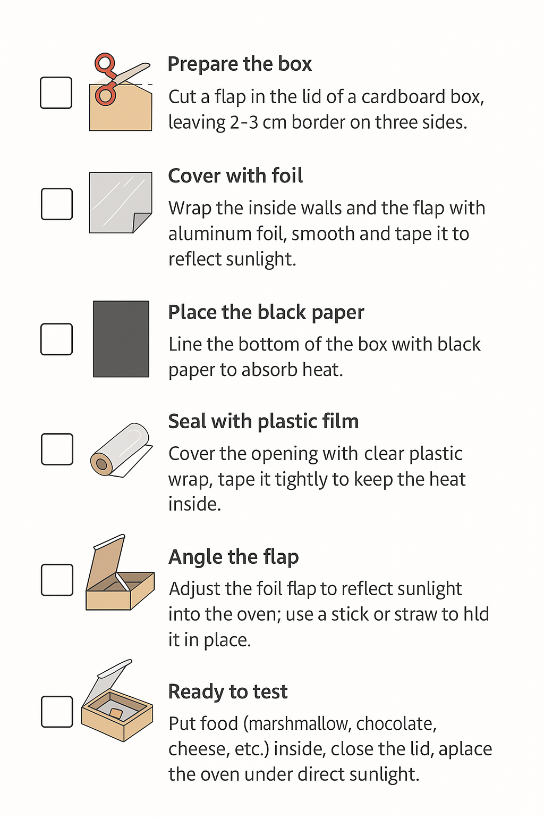
(Optionally, Teacher can hand out this visual as check list to students)
Activity 3
Measuring and Recording (Drag & Drop)
In this activity, after completing your solar oven, it’s time to test how effectively it captures and retains heat:
Steps:
- Place food (chocolate, marshmallow) in your solar oven.

- Measure the temperature every 10 minutes with a thermometer and record the data:

Time | Temperature (°C) | Entered into FOSSBot (✓)
0 min
10 min
20 min
- Complete the digital drag-and-drop activity (H5P): Match each temperature with the correct observation. (Example: 25°C → No cooking yet, 33°C → Chocolate softens, 44°C → Marshmallow melts.)
Teacher / H5P Note:
- Use Drag and Drop content type in H5P.
- Create 3 drop zones (No cooking yet, Chocolate softens, Marshmallow melts).
- Add draggable temperature cards (25 °C, 33 °C, 44 °C, etc.)
- Configure Check, Retry, Show solution for feedback.

Activity 4

Material Comparison
In this stage, students will compare the effectiveness of different solar oven designs to see which materials work best in capturing heat.
Test your group’s oven and note below the maximum temperature reached.
- ____________________

- Compare with another group’s result (foil vs. plain).
_______________________________________________________________________________________________________________________________________________________________________________________________________________
- Record here:

- Foil Oven: ______ °C
- Plain Oven: ______ °C
Which one worked better? Why?
______________________________________________________________________________________________________________________________________________________________________________________________________________________________________________________________________________________________________________________________________________________________________________________________________________________________
Activity 5

Reflection

In the final activity, students will reflect on what you have learned and connect the solar oven experiment to everyday sustainable habits.
Steps:

Part A – Game Steps
Follow these steps with your group:
- Start the Game
- Place FOSSBot on the line track.
- Press the button to begin.
- Line Following
- FOSSBot moves forward, following the black line.
- Watch carefully for the marker points.
- Marker Stop (3-second countdown)
  - At each marker, FOSSBot stops.
  - A green LED starts blinking (3 seconds).
- Decision Time
  - If you press the button within 3 seconds → Engine OFF (green LED + short beep, 0 points).
  - If you do not press the button → Engine Idling (red LED + long beep, +2 points).
- Continue
  - After each decision, FOSSBot moves to the next marker.
  - There are 3 markers in total.
- Game Over – Score Summary
  - FOSSBot shows the results with LED flashes and buzzer tones:
    - Green flashes = times you turned off the engine.
    - Red flashes = times you idled.
    - Long red flashes = your total idle score.
To run the game follow these steps:
- Open the FOSSBot App.
- Go to the home page of the FOSSBot interface.
- Upload  the project “Idle-Off Game.xml”.
- Click Edit.
- Run the project.

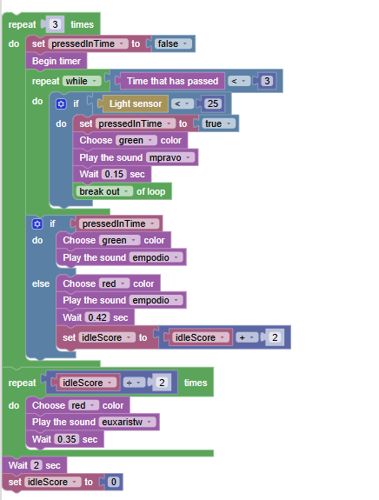

Part B - Reflection Questions
- How many times did your team idle instead of turning off?
→ _______ times
- What was your total idle score?
→ _______ points
- Why is it important to avoid engine idling in real life?
→ ______________________________________________________
- What are some everyday actions you can take to reduce unnecessary energy use?
→ ______________________________________________________

Note: To implement the activities, the FOSSBot must be pre-synchronized with the local Wi-Fi network and pre-programmed with the appropriate automated behavior logic.

