SCENARIO TITLE
Discovering Atapuerca: Challenges through the STEAM Approach
SUBJECT
Integrated STEAM Education

1. SCENARIO IDENTIFICATION
1.1 Scenario Title
Discovering Atapuerca: Challenges through the STEAM Approach
1.2 Target Age group
6th grade of Primary Education and 1st grade of Compulsory Secondary Education (ESO), adaptable to higher levels.
Curriculum: Primary Education and ESO.
Thematic area: Social Sciences, Technology, Engineering.
Topics/Subtopics: STEAM, computational thinking.

1.3 Estimated Duration
50 minutes
1.4 Subject Areas Involved
STEAM disciplines (Science, Technology, Engineering, Arts, and Mathematics)
1.5 Prerequisite Knowledge
- Students should have previous familiarity with a programming environment.
- Possess basic computational skills.
1.6 Purpose of the Scenario
The purpose of this lesson is for students to understand how human beings lived during Prehistory while learning to operate an educational robot as an exploration tool. Through the use of the FOSSbot and visual programming with Blockly, students will carry out activities that simulate movements, discoveries, and forms of organization of prehistoric groups. In this way, technology becomes a resource for representing historical processes, fostering active learning, motivation, and logical thinking. The integration of Social Sciences and Technology enables a more meaningful understanding of the past and the responsible use of digital tools.
    - Lerarning Objectives / Outcomes
Students will:
- Understand the main stages of Prehistory and their evolution.
- Analyze the social organization of prehistoric human groups.
- Begin developing basic skills in operating the FOSSbot robot as a learning tool.
- Become familiar with the functions and basic programming of the FOSSbot robot.
- Present the technical specifications and operational functionalities of the FOSSbot robot as an educational resource.

    - Teaching Objectives:
The educator aims to:
- Promote a transdisciplinary approach to learning, integrating knowledge and skills from various curricular areas through meaningful and contextualized experiences.
- Develop key 21st-century competencies such as computational thinking, scientific and technological literacy, heritage awareness, creativity, personal autonomy, and teamwork.
- Foster peer collaboration through joint problem-solving and role distribution, encouraging effective communication, shared decision-making, and respect for group ideas.
- Apply active methodologies such as Project-Based Learning (PBL) and Challenge-Based Learning (CBL) to solve real-world problems through collaborative design, research, and experimentation.
- Use educational robotics as a pedagogical tool to transform the teaching-learning process from an integrated, critical, and holistic STEAM perspective.
2. LESSON PLAN DEVELOPMENT

The lesson is based on a transdisciplinary approach that facilitates the coherent and meaningful integration of knowledge from various curricular areas, fostering a holistic view of learning.
The sequence of activities is designed following the Project-Based Learning (PBL) methodology, organized around a highly relevant central theme: the archaeological site of Atapuerca. This theme serves as an integrating and motivating context from which multiple interrelated challenges emerge that students must collaboratively address, thereby promoting teamwork and collective knowledge building.
Simultaneously, the implementation of an integrated STEAM approach is incorporated, where a FOSSbot robot becomes an essential mediating tool to facilitate a more dynamic and motivating interconnection of content.
Simultaneously, the implementation of an integrated STEAM approach is incorporated, in which a FOSSbot robot becomes an essential mediating tool to facilitate a more dynamic and motivating interconnection of content.
Content:
Table 1. Relationship of content by disciplinary area
Disciplinary Area | Content
Social Sciences | - Stages of Prehistory.  - Understanding the social organization of prehistoric human groups.  - Historical contextualization with the Atapuerca site.
Technology | - Basic functions and programming of the FOSSbot robot.
Engineering | - Basic actions of the FOSSbot robot using visual platforms such as Blockly.  - Elementary instructions.

2.1 Description of Teaching and Learning Activities
Materiale:
- Map of the Atapuerca site
- Photographs of the site and findings from different historical periods
- Visual timeline of the prehistoric stages
- Individual worksheets for students
Activity 1
The lesson begins with an activity aimed at activating prior knowledge and providing a preliminary approach to the key concepts of the topic. Students, organized in groups of 4 to 5 members, participate in a brainstorming session based on the questions: “What do we know about prehistory?” and “What do we know about our ancestors?” This allows the teacher to gather information about the students’ initial ideas, experiences, and notions before starting the content development.
Additionally, the FOSSBot robot is introduced, and questions related to it are asked, such as: “What do you think this is?” “What can I use it for?” “How can I make it work?”
Activity 2
Under the teacher’s guidance, students collaboratively create a concept map on the digital whiteboard, collecting the main concepts related to the stages of Prehistory. For the same purpose, the FOSSBot robot is shown. This strategy helps identify alternative conceptions, activate prior cognitive schemas, and provide an initial structured approach to the contents that will be worked on in the unit.
Afterwards, students are asked to complete a worksheet about their prior knowledge, expectations for learning, and something that surprised them during the lesson.
Afterwards, students are asked to complete a worksheet about their prior knowledge, expectations for future learning, and something that surprised them about what they observed during the lesson.
Actividad 3
To conclude, a brief introduction of the FOSSBot robot as an educational tool is presented, which will accompany students during upcoming sessions. Its basic functionalities are shown (power on, Internet connection, interface, new project, etc.), usage simulations are demonstrated, and its usefulness for activities related to archaeology that will be covered in future lessons is highlighted.

2.2 Worksheets
Activity 2
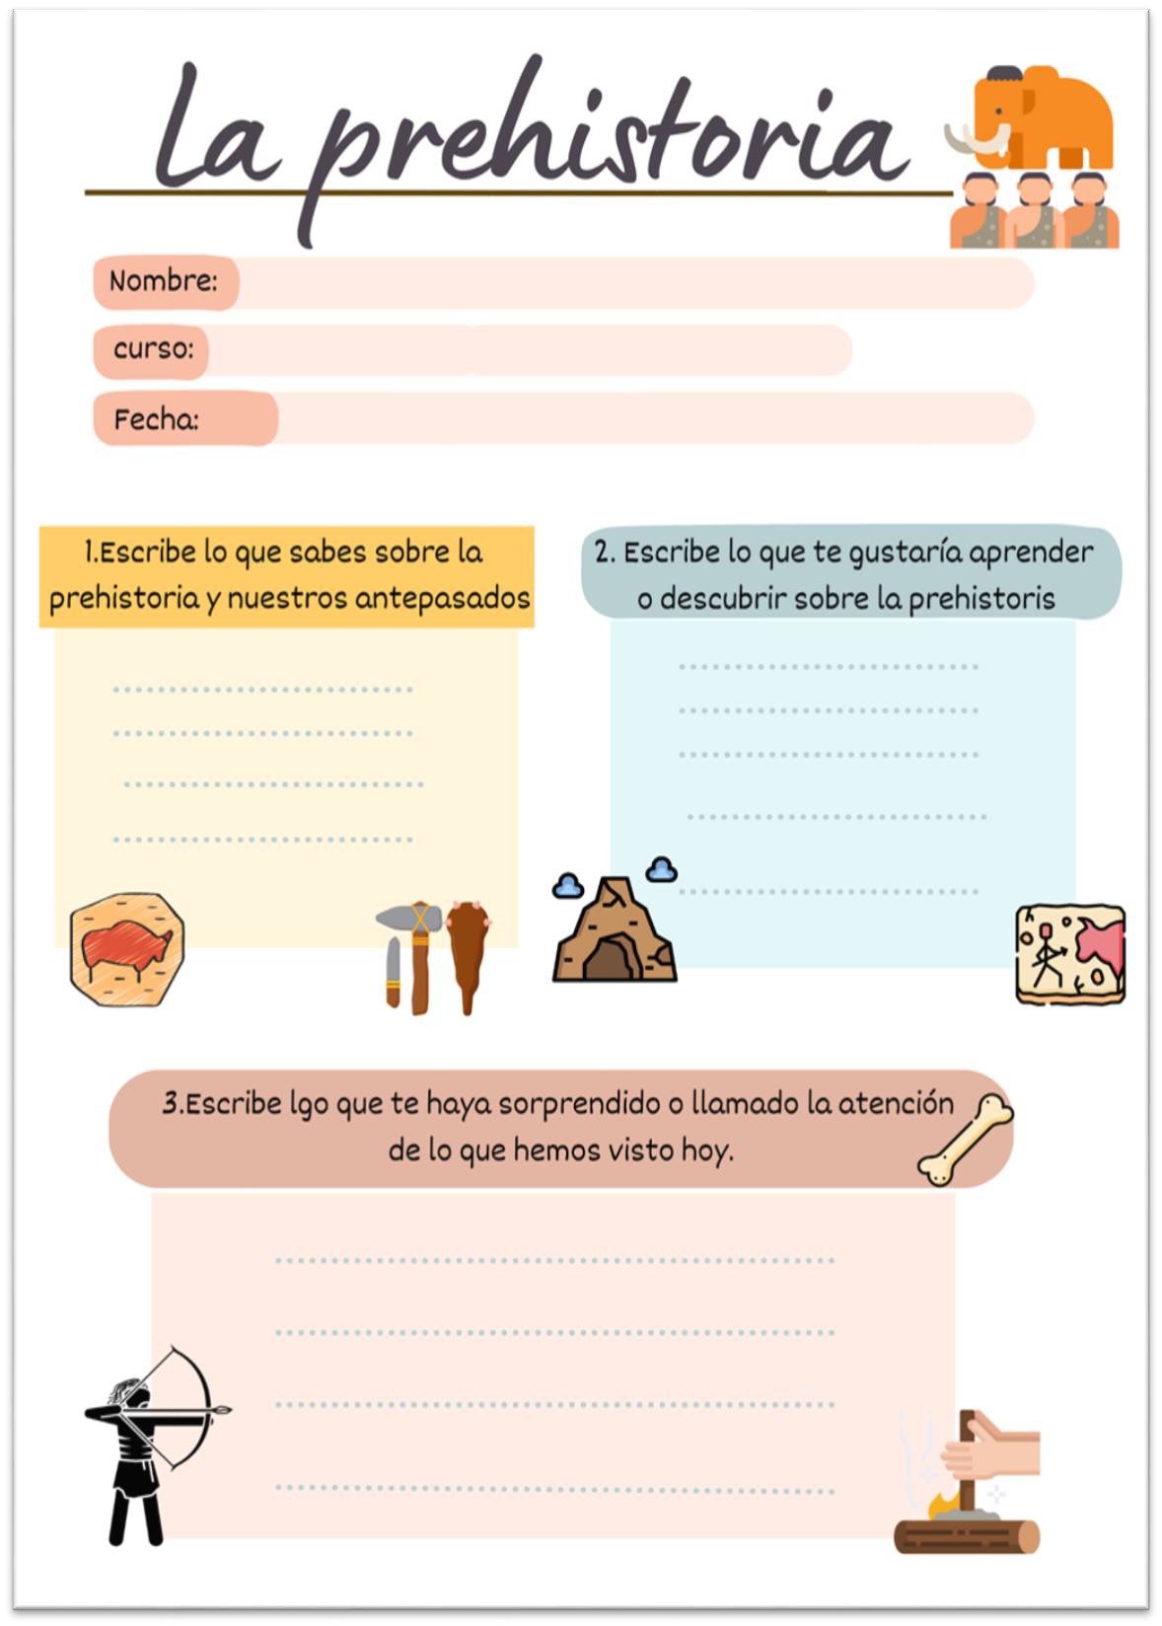
Figure 1. Example of a worksheet on prior knowledge.
Activity 3
Basic knowledge of the FOSSBot robot, such as::
- Main page  of the FOSSBot interface.
- New Project .
- Load the project
- Edit.
- Run  the project.

