SCENARIO TITLE
Draw with Code! – Discover Programming through Geometric Shapes

SUBJECT
Programming

1. SCENARIO IDENTIFICATION
1.1 Scenario Title
Draw with Code! – Discover Programming through Geometric Shapes

1.2 Target Age Group
Grades 7–9 (Junior High School)
Curriculum: Junior High School
Thematic Area: Computational thinking, physical computing
Topics/Subtopics: Basic programming concepts, geometry, robotics and automation
Expected Learning Outcomes:
Students will be able to:
- Use a visual programming interface to control robot movements.
- Program the robot to draw simple geometric shapes (square, triangle, circle approximation).
- Understand and apply loops, sequences, and angle-based logic.
- Translate geometric knowledge into algorithmic instructions.
- Collaborate to debug and improve code for more precise drawings.
1.3 Estimated Duration
45 minutes

1.4 Subject Areas Involved
Computer Science, Mathematics, Technology

1.5 Prerequisite Knowledge
Students should:
- Know how to use a visual programming environment .
- Understand the basic concept of movement (forward, turn) and rotation angles.
- Be able to identify basic geometric shapes and their properties (number of sides, angles).

1.6 Purpose of the Scenario
To introduce programming logic and robotics through an engaging and creative drawing activity.

1.6.1 Learning Objectives/Outcomes
Students will:
- Operate the FOSSBot programming environment.
- Program movement and rotation commands to produce geometric patterns.
- Apply concepts of angles and repetition (loops) in practical tasks.
- Develop creativity and problem-solving through testing and iteration.

1.6.2 Teaching Objectives
The educator aims to:
- Foster understanding of sequences and logical instructions.
- Link mathematical concepts with coding applications.
- Promote collaborative exploration and debugging.
- Encourage creativity through drawing-based challenges.

2. LESSON PLAN DEVELOPMENT
2.1 Description of Teaching and Learning Activities
This scenario employs experiential and inquiry-based learning using the FOSSBot and its visual programming environment.
The learning process focuses on exploration, encouraging students to experiment with commands and conditions by creating an interactive project. No ready-made solutions are provided, promoting knowledge discovery through observation and trial.
Collaborative learning is enhanced through teamwork, as students work in groups of 3–5 to develop their projects, strengthening social interaction and collective knowledge construction.
The scenario integrates gamification elements, adding motivation and engagement to the learning experience. Students create interactive projects using sensors, LEDs, and the computer screen, evoking gameplay experiences.
A worksheet is used for instruction, guiding students through five (5) consecutive activities:
Activity 1: Introduction to the FOSSBot interface and programming environment. Using an image with interactive hotspots, students identify the main functions of the environment.
Activity 2: Understanding the programming environment and the basics of robot movement. In this activity, students will explore the FOSSBot interface and learn how to use basic movement commands to control the robot. They will gain confidence in launching programs, adjusting parameters, and observing how simple code translates into real movement.
Activity 3: Creating geometric shapes and discovering repetition. Students will program the robot to draw basic geometric figures such as squares and triangles. Through this process, they will begin to recognize patterns in the instructions and understand how repetition plays a key role in simplifying their code.
Activity 4: Introducing advanced repeat blocks to simplify complex shape creation. Building on their earlier work, students will use repeat loops to optimize their programs. By learning how to control the number of iterations and the angles of rotation, they will be able to draw more complex shapes with fewer commands, reinforcing both coding efficiency and geometric reasoning.
Activity 5: Understanding check and enhancement of metacognitive awareness via a structured questionnaire (multiple choice and true/false questions) covering concepts from previous activities.
To implement the activities, the FOSSBot must be pre-synchronized with the local Wi-Fi network.

2.2 Worksheets
Activity 1
Familiarization with the FOSSBot Programming Environment
Using an Image Hotspots tool (such as https://h5p.org/image-hotspots), interactive points will be created on the buttons of the image below to describe the function of each one:
- Save Code
- FOSSBot Interface Homepage
- Run Program
- Stop Program Execution
- Trash Bin
- Blocks Palette
- Tile Drop Area
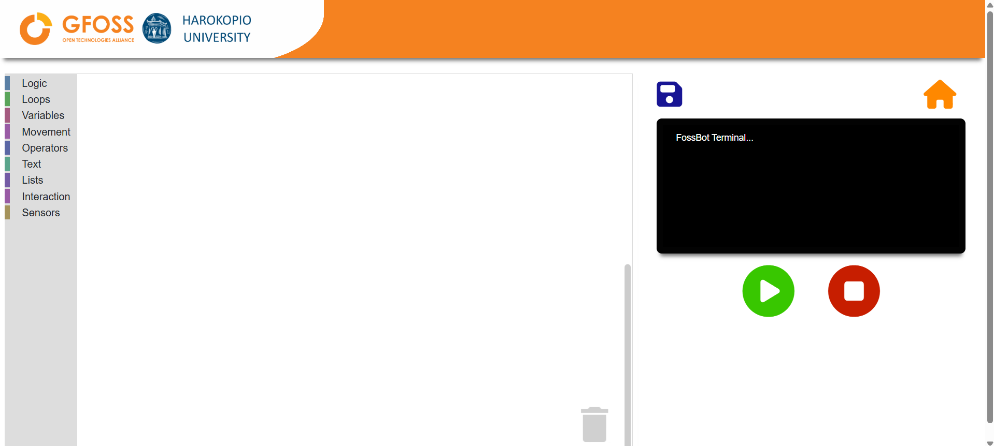

Activity 2
Familiarization with the FOSSBot Programming Environment
- Open the FOSSBot. Wait a few seconds for it to connect to your local network.
- On a computer or laptop connected to the same network as the robot, open Chrome or Firefox and go to the URL: http://fossbot-000.local:8081 to access the FOSSBot interface.
- Place a pencil in the designated holder on the robot, making sure it is secure and points downward for proper drawing.
- Upload the project “Draw with FOSSBot - Introduction.xml”.
- Click Edit.
- Run the project.
- What do you observe?
………………………………………………………………………………………………………………………..
- What changes are needed for the robot to draw a complete square?
……………………………………………………………………………………………………………………..
- What modifications are needed for the robot to draw a 30 cm square?
……………………………………………………………………………………………………………………..

Activity 3 - Geometric Shapes
- Go to the homepage of the FOSSBot interface.
- Create a new project .
- Name it “My First Drawing”.
- In the “short description for the new project,” you may write:
“A simple program that makes the robot draw its first geometric shape”
- We will start by recreating the loop from Activity 1, which allows the robot to draw a square. Create this simple program.
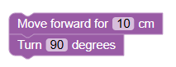
As you may have noticed, the “turn” block is not exactly the same as the one used earlier. In this block, you can set the desired angle.

- Run the program with and add blocks so the robot draws a square with 10 cm sides.
- Now try to draw a rectangle measuring 10 by 20 centimeters.
- Modify the program to draw a triangle :
  - How many times do you need to turn?…………………………………………
  - And what angle do you need to turn? …………………………………………
- Now let’s try to draw a hexagon :
  - How many times do you need to turn?…………………………………………
  - And what angle do you need to turn? …………………………………………
- As you have seen, for each regular geometric shape, you had to repeat the same operations several times. What are these operations?
……………………………………………………………………………………………………………………………………………………………………………………………………………………………………………

Activity 4 - Loop
In this activity, we will now simplify and improve the previous programs by using loop tools.
- We will enhance the code from Activity 3. To create a copy of it, go to the homepage of the FOSSBot interface. Select Export and then Import . Then, enter edit mode .
- In the toolbar, go to the Loops tab and select the repeat 10 times block.
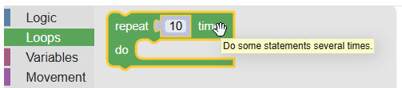
- What do you think this block is used for?
…………………..…………………………………………
What does the number inside the block represent?
…………………………………………………………….
- Modify your program to draw a square using the repeat block.
- What is the number of repetitions you used to draw this square?
…………………………………………………………….
- Now modify your program to draw a triangle.
  - What is the number of repetitions? ………………………………..
  - What angle should you set? ……………………………
- Now try the same exercise with a hexagon.
- Can you draw a pentagram using the same instructions you used to create geometric shapes earlier?
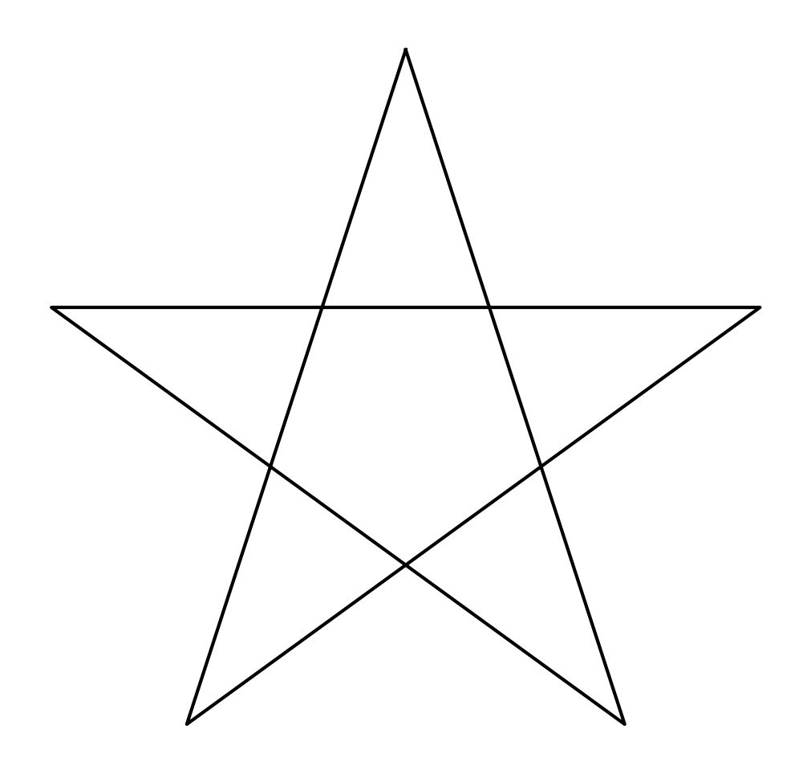
To help you:
  - how many lines does a pentagram have?
…………………………………….
  - how much should you turn at each point of the star's branches?
…………………………………….

Activity 5
Knowledge Assessment Activities
- Which of the following buttons creates a new project in the FOSSBot interface?
  - 
- In which block palette can someone find the command “repeat”?
  - Logic
  - Loops
  - Interaction
  - Sensors
- How many times do you need to turn to draw a square?
  - 3
  - 4
  - 5
  - 6
- What angle should you use to draw a triangle?
  - 60°
  - 90°
  - 120°
  - 180°
- What does the number inside the repeat block represent?
  - The number of commands in the program
  - The number of turns
  - The number of times a group of commands will run
  - The number of sides the shape has
- To draw a hexagon, what is the correct rotation angle?
  - 45°
  - 60°
  - 90°
  - 120°
- To create a star (pentagram), the robot should turn 144° at each corner.
  - True
  - False
- All regular polygons can be drawn using the repeat loop and a fixed rotation angle.
  - True
  - False
Correct Answers:
1.c, 2.b, 3.b, 4.c, 5.c, 6. b, 7. True, 8. True

