SCENARIO TITLE
Observation Game

SUBJECT
Programming / Environmental Protection

1. SCENARIO IDENTIFICATION
1.1 Scenario Title
Observation game
1.2 Age Group
Grade 7 (Junior High School)
Curriculum: Junior High School

Thematic Area: Algorithms and Computer Systems Programming, Environmental Protection

Topics/Subtopics: Problem solving with programming tools. Robot programming and automation
Expected Learning Outcomes:
Students will be able to:
- Use and program FOSSBot light sensors for environmental issues
- Design and implement algorithmic structures, such as multiple choice and iteration
- Modify code using variables and random number generators
- Develop teamwork and problem-solving skills through experiential and exploratory activities
- Be aware of environmental protection issues.
- Associate environmental protection concepts with specific colors.

1.3 Estimated Time
45 minutes.
1.4 Subject Areas Involved
Scenario topic:
Use of educational robotics for environmental monitoring and student awareness, through an observation game.
Cognitive objects:
- Computer Science: Algorithmics, visual programming, control structures (multiple choice) and iteration, use of variables, sensors, automation.
- Environmental Education: Raising awareness about environmental protection, sustainable development, recycling, energy and water conservation.
- Natural Sciences: Interaction of physical quantities (light) with technological systems.

1.5 Prerequisite Knowledge
It is legitimate for students to:
- Have basic familiarity with visual programming environments such as Scratch
- Understand basic programming concepts, such as iteration structures and multiple choice structures
- Have basic knowledge of the concept of sensors and their use in simple automation systems
- Have basic experience using FOSSBot
- Have the ability to work in small teams (3-5 people)

1.6 Purpose of the Scenario
The scenario seeks to connect programming with environmental awareness. Through an observational game, students will learn to use technological tools (such as the FOSSBot and its sensors) to observe and understand environmental problems. They also develop algorithmic thinking, collaboration, and problem-solving skills.

1.6.1 Learning objectives/Outcomes
Upon completion of the educational scenario, students will be able to:
- Connect FOSSBot to the network and upload programs.
- Create programs with variables and random number generators.
- Apply the multiple-choice structure to match various colors with specific environmental concepts.
- Modify the code to repeat a process, for example, until the light sensor is blocked.
- Use a light sensor to create applications with an environmental purpose.

1.6.2 Educational objectives
The scenario seeks to:
- Promote experiential and inquiry-based learning.
- Enhance collaborative learning in small groups of students.
- Offer an understanding of the relationship between technology and environmental monitoring.
- Develop critical thinking and problem-solving skills through experimentation and testing.
- Raise awareness among students about the use of technology with a social orientation and ecological awareness.

2. LESSON PLAN DEVELOPMENT
2.1 Description of teaching and learning activities
Teaching is based on experiential and inquiry-based learning. Students work in small groups (3-5 people), programming the FOSSBot while taking part in an observation game.
The flow of activities includes:
- Activity 1: Students play a 7-pair matching game on the theme of environmental protection, using h5p Image pairing.
- Activity 2: Students open h5p Drag the Words and drag the appropriate color to each environmental protection category. The colors correspond to specific concepts: blue for saving water , green for recycling , yellow for saving energy, white for reducing waste, cyan for planting trees, red for sustainable transportation and violet for composting .
- Activity 3: Students connect to FOSSBot, upload a finished project and are asked to observe the robot's behavior.
- Activity 4: Modify the code by creating a variable that accepts values from a random number generator (1-7) and programming the FOSSBot 's white light to blink as many times as the value of the variable.
- Activity 5: Use a multiple-choice structure for 7 cases. Each case corresponds to a different color and number of repetitions (1 time for white, 2 for blue, 3 for green, 4 for yellow, 5 for cyan, 6 for red, 7 for violet) . Refactor the code so that the steps are repeated until the light from the light sensor is blocked .
The educational process is enhanced by the integration of gamification and interactive assessment elements through the H5P platform.
To implement the activities, FOSSBot must first be synchronized to the local Wi - Fi network.

2.2 Worksheets
Activity 1​

Students are invited to play on h5p Image pairing, a matching game of 7 pairs of images on the theme of environmental protection.

The image pairs that will be used in h5p Image pairing are located in the folder “Images pairing h5p"
2nd ^{Activity}​
Open Drag the Words on h5p. In each blank, drag the color that you think best fits each category for environmental protection.

The word-sentences that will be used in h5p are the following:
Water Saving: Blue. The most obvious color for water.
Recycling: Green. Global symbol of recycling and environmental protection.
Energy Saving: Yellow. It is reminiscent of the sun, a renewable energy source, and symbolizes brightness and light, emphasizing savings.
Waste Reduction: White. Symbolizes purity and cleanliness, which fits with the idea of a waste-free environment.
Tree Planting: Cyan. It will be used next as a different shade that FOSSBot has instead of the recycling green.
Sustainable Transportation: Red. A bright color that attracts attention and can symbolize the "cessation" of polluting transportation, such as cars, in favor of greener solutions.
Composting : Violet. It is associated with creation, transformation, and the mystery of nature. It fits with the composting process that transforms organic waste into something new and beneficial.

Activity 3​
- Open FOSSBot. Wait a few seconds for it to connect to your local network.
- On a computer or laptop connected to the same network as FOSSBot, open Chrome or Firefox and go to the URL: http://fossbot-000.local:8081 to view the bot interface.
- Upload the “Observation” task black box.xml ”.​
- Click edit
- Execute the project.
- What do you notice?
……………..…………………………………………………………………………………………………………………………………………………………………………………………………………………………………..
Activity 4 ​
Using a random number generator
- Using the code from Activity 3, modify your program by following these steps:
  - Create a variable “counter” (Create Variable-counter)
  - Use a random number generator from 1-7
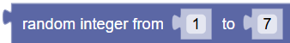
  - The variable “counter” should accept values from the random number generator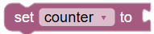
  - The white light of the FOSSBot will flash according to the values it receives from the random number generator
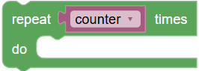
Activity 5​
Multiple choice structure for color selection with appropriate repetitions
- Using the code from the activity 4 , modify your program using the multiple- choice structure for 7 cases.
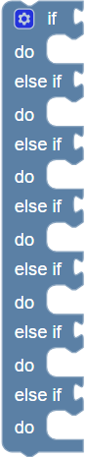
- In the 1st ^{case} the white light will flash once. This will be done with the code
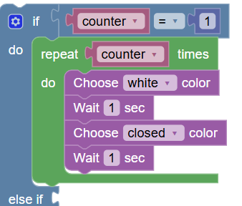
- Continue in the same way for 6 more colors
  - Blue: 2 repetitions
  - Green: 3 repetitions
  - Yellow: 4 repetitions
  - Blue: 5 repetitions
  - Red: 6 reps
  - Violet: 7 reps
- When you perform the project, how many times is the color change repeated?
……………………………………………………………………………………………………………………….
- Modify the code to repeat the above steps continuously until you "block" the light on the light sensor.
